**TRAFFIC CONGESTION DETECTION**

**AND MANAGEMENT USING VEHICULAR AD-HOC**

**NETWORK**

**PROJECT REPORT**

**ABSTRACT**

The vehicular Ad-hoc network, or VANET, is for sharing of emergency and safety information among vehicles to ensure safe travelling of users in road. It is the technology that uses moving cars as nodes to create a mobile network, VANET turns every participating car into wireless router or node, allowing cars to establish communication. Vehicles can communicate within themselves (V2V) and also with the road side units (V2I).vehicles communicating with other vehicles are expected to have the potential to enhance the driving experience, awareness, situation perception and thus safety. In response to the problem of drastically increasing road accidents and climatic disasters like smoke, fog etc. we have designed and tested in various traffic scenarios of Kathipara, T.Nagar, highway and village. Each scenario is very different from each other; like kathipara has moderate real time traffic, T.Nagar has extensive real time traffic, highways with irregular traffic and villages which had very few vehicles. We designed the placement of RSUs(Road Side Units) in each scenario and we analysed the delay and packet delivery ratios(PDR) in each scenario. These results would guarantee the use of VANET in real time.

**TABLE OF CONTENTS**

|  |  |  |
| --- | --- | --- |
| **CHAPTER NO.** | **TITLE** | **PAGE NO.** |
|  |  |  |
|  | **ABSTRACT**  **ACKNOWLEDGEMENT** | **iii**  **iv** |
|  | **LIST OF TABLES** | **ix** |
|  | **LIST OF FIGURES** | **x** |
|  | **LIST OF ABBREVIATIONS** | **xiv** |
| **1** | **INTRODUCTION** |  |
| 1.1  1.2  1.3  1.4  **2**  2.1  2.2  2.3  2.4  2.5    2.6  **3**  3.1  3.2  3.3  **4**  4.1  4.2  4.3  4.4  4.5  **5**  5.1  5.2  5.3  5.4  5.5  5.6    5.7  **6**  6.1  6.2 | OVERVIEW OF VANET  PROBLEM STATEMENT  1.2.1 PROBLEM 1  1.2.2 PROBLEM 2  VEHICULAR AD-HOC NETWORKS(VANETS)  AS A SMART SOLUTION  OBJECTIVES  **VANET BASICS**  CHARACTERISTICS OF VANET  VANET-ARCHITECTURE  MAIN COMPONENT  COMMUNICATION ARCHITECTURE  ROUTING IN VANET  AD-HOC ROUTING PROTOCOLS  2.6.1 TABLE DRIVEN ROUTING PROTOCOLS-  PROACTIVE  2.6.2 ON-DEMAND ROUTING PROTOCOLS-  REACTIVE  2.6.3 HYBRID(BOTH PROACTIVE AND  REACTIVE)  2.6.4 COMPARISON OF AODV AND DSDV  **WORKING OF VANET**  INTELLIGENT TRANSPORTATION SYSTEM  3.1.1 VEHICLE TO VEHICLE  COMMUNICATION  3.1.2 VEHICLE TO INFRASTRUCTURE  COMMUNICATION  METHODOLOGY  PROPOSED SYSTEM MODEL  **VANET FOR BOATS**  INTRODUCTION  CHARACTERISTICS  PRESENT COMMUNICATION IN BOAT  PROPOSED SYSTEM  ARCHITECHTURE  4.5.1 BASE STATION AT LAND  4.5.2 BOAT SIDE INFRASTRUCTURE(BSI)  **SIMULATION & RESULTS**  SOFTWARE USED  5.1.1 SUMO-SIMULATION OF URBAN  MOBILITY  5.1.2 NS2-NETWORK SIMULATOR  MODELLING  5.2.1 TRAFFIC MODEL  5.2.2 COMMUNICATION MODEL  TRAFFIC MODELLING-MANUAL  ROAD DESIGNING  TRAFFIC MODELLING-REAL-TIME  MAP DESIGNING  5.4.1 THE KATHIPARA SCENARIO  5.4.2 T.NAGAR SCENARIO  5.4.3 VILLAGE SCENARIO  5.4.4 HIGHWAY SCENARIO  COMMUNICATION MODEL  5.5.1 AODV ANALYSIS  5.5.2 RSU-RSU COMMUNICATION  5.5.3 VEHICLE-TO-VEHICLE  COMMUNICATION  5.5.4 VANET- MANUAL  5.5.5 VANET- REAL TIME  OVERALL REAL-TIME SIMULATION  5.6.1 KATHIPARA SCENARIO  5.6.2 T.NAGAR SCENARIO  5.6.3 VILLAGE SCENARIO  5.6.4 HIGHWAY SCENARIO  5.6.5 ANALYSIS OF VANET-REAL TIME  VANET FOR BOATS-SIMULATION  **CONCLUSION AND FUTURE WORK**  CONCLUSION  FUTURE WORK  6.2.1 LAND SCENARIO  6.2.2 MARINE SCENARIO  **REFERENCES** | 1  1  1  2  3  4  5  6  7  9  11  12  13  14  16  16  18  18  18  20  20  23  23  23  24  24  24  24  25  25  25  26  26  26  27  29  30  31  32  32  34  34  36  36  41  43  44  45  46  48  50  51  53  53  53  54  55 |

**LIST OF TABLES**

|  |  |  |
| --- | --- | --- |
| **TABLE**  **NO.** | **TITLE** | **PAGE**  **NO.** |
| 5.1  5.2  5.3  5.4  5.5  5.6  5.7 | Packet Delivery Ratio for V2V – Scenario 1  End to End delay for V2– Scenario 1  Packet Delivery Ratio for V2V – Scenario 2  End to End delay for V2V– Scenario 2  Packet Delivery Ratio for VANET Manual  End to End delay for VANET Manual  Analysis of VANET-Real time | 38  38  40  40  42  42  50 |

**LIST OF FIGURES**

|  |  |  |
| --- | --- | --- |
| **FIGURE NO** | **TITLE** | **PAGE NO** |
| 2.1 | VANET-OVERVIEW | 6 |
| 2.2 | COMPONENTS OF VANET | 7 |
| 2.3 | VANET-ARCHITECTURE | 8 |
| 2.4 | VANET -COMMUNICATION ARCHITECTURE | 9 |
| 2.5 | ROUTING IN VANET | 10 |
| 2.6 | AD-HOC PROTOCOLS | 13 |
| 2.7 | DSDV ROUTING | 14 |
| 2.8 | AODV ROUTING | 15 |
| 2.9 | AODV VS DSDV | 17 |
| 3.1 | VANET METHODOLOGY | 20 |
| 3.2 | VANET MODEL | 21 |
| 4.1 | VANET FOR BOATS-ARCHITECTURE | 24 |
| 4.2 | BOAT SIDE INFRASTRUCTURE-BUOY | 24 |
| 5.1 | SIMULATION OF TRAFFIC MODEL | 27 |
| 5.2 | KATHIPAR SIMULATION | 30 |
| 5.3  5.4  5.5  5.6  5.7  5.8  5.9  5.10  5.11  5.12  5.13  5.14  5.15  5.16  5.17  5.18  5.19  5.20  5.21  5.22  5.23  5.24  5.25  5.26  5.27  5.28  5.29 | T.NAGAR SIMULATION  VILLAGE SIMULATION  HIGHWAY SIMULATION  AODV ANALYSIS 1  AODV ANALYSIS 2  RSU-TMC-RSU COMMUNICATION  V2V COMMUNICATION SCENARIO 1  PDR FOR V2V -SCENARIO 1  E2E DELAY FOR V2V – SCENARIO 1  V2V COMMUNICATION- SCENARIO 2  PDR FOR V2V-SCENARIO 2  E2E DELAY FOR V2V-SCENARIO 2  VANET MANUAL – 5 NODES  VANET MANUAL – 50 NODES  PDR FOR VANETMANUAL  E2E DELAY FOR VANET MANUAL  SUMO FILE  -KATHIPARA  NS2 FILE  –KATHIPARA  SUMO FILE –  TNAGAR  NS2 FILE –  TNAGAR  SUMO FILE –  VILLAGE  NS2 FILE-VILLAGE  VILLAGE VANET SCENARIO  SUMO FILE –HIGHWAY  NS2 FILE-HIGHWAY  ANALYSIS OF VANET –REAL TIME  VANET FOR BOAT SIMULATION | 31  32  33  35  35  36  37  38  38  39  40  40  41  41  42  42  44  44  45  45  46  46  47  48  48  50  52 |

**LIST OF ABBREVIATIONS**

VANET Vehicular Ad hoc Network

WLAN Wireless Local Area Network

ITS Intelligent Transportation System

IVC Inter-Vehicular Communication

RVC Road-Vehicular Communication

V2V Vehicle-to-Vehicle Communication

V2I Vehicle-to-Infrastructure Communication

I2I Infrastructure-to-Infrastructure Communication

RSU Road-Side Unit

MANET Mobile Ad hoc Network

RSA Rivest–Shamir–Adleman algorithm

ECDSA Elliptic Curve Digital Signature Algorithm

DSRC Dedicated Short Range Communication

ACC Adaptive Cruise Control

TMC Traffic Management Centre

V2X Vehicle to Everything

OBU On-Board Unit

AU Application Unit

HSs Hotspots

GSM Global System for Mobile Communication

GPRS General Packet Radio Services

UMTS Universal Mobile Telecommunications System

WiMax Worldwide Interoperability for Microwave Access

4G 4th Generation

V2B Vehicle to Broadband cloud

FCC Federal Communications Commission

WAVE Wireless Access in Vehicular Environment

IEEE Institute of Electrical and Electronics Engineers

IPv6 Internet Protocol version 6

TCP Transmission Control Protocol

UDP User Datagram Protocol

AODV Ad hoc On-Demand Distance Vectore

DSDV Destination-Sequenced Distance-Vector

OLSR Optimized Link State Routing

TBRPF Topology Broadcast-focused around Reverse-Path Forwarding

DSR Dynamic Source Routing

RREQ Route Request

RREP Route Reply

BSI Boat-Side Infrastructure

B2B Boat-to-Boat

VHF Very High Frequency

UHF Ultra-High Frequency

LOS Line Of Sight

QPSK Quadrature Phase Shift Keying

QAM Quadrature Amplitude Modulation

SUMO Simulation of Urban Mobility

GPL General Public License

NS Network Simulator

OSM Open Street Map

GUI Graphical User Interface

PDR Packet Delivery Ratio

E2E End-to-End

**CHAPTER - 1**

**INTRODUCTION**

**1.1 OVERVIEW OF VANET**

India is among the fast developing nations in the world which have the highest density of public and private vehicles. The logistics sector in India is playing an important role in developing the stable economic growth of the country due. The volume of freight traffic movement has been dramatically increased in the country. This outsized level of traffic makes a huge grown in all aspects of logistics with [transportation](http://loadjunction.com/transport/index.php), warehousing, freight forwarding, express cargo delivery, container services, shipping services etc.

It has always been a cumbersome task to manage traffic in India. Traffic congestion occurs when a volume of traffic or [modal split](https://en.wikipedia.org/wiki/Mode_choice) generates demand for space greater than the available street capacity; this point is commonly termed [saturation](https://en.wikipedia.org/wiki/Degree_of_saturation_(traffic)). There are a number of specific circumstances which cause or aggravate congestion; most of them reduce the capacity of a road at a given point or over a certain length, or increase the number of vehicles required for a given volume of people or goods.

High traffic density is result of variable predictable and unpredictable factors. Predictable factors include road construction sites or peak hours of travel (i.e. office hours) about which drivers are aware, whereas unpredictable factors include weather conditions, accidents and human behaviour.

Traffic research still cannot fully predict under which conditions a "traffic jam" (as opposed to heavy, but smoothly flowing traffic) may suddenly occur. It has been found that individual incidents (such as accidents or even a single car braking heavily in a previously smooth flow) may cause ripple effects (a [cascading failure](https://en.wikipedia.org/wiki/Cascading_failure)) which then spread out and create a sustained traffic congestion when, otherwise, normal flow might have continued for some time longer. Such congestion problems can be avoided if drivers are pre-aware of these traffic bottlenecks.

**1.2 PROBLEM STATEMENT**

**1.2.1 PROBLEM 1**

In India, **17** people die every hour due to road accidents, which is highest in the world. This is due to lack of road-safety infrastructure, high number of vehicles leading to heavy traffic jams and fatal collisions.

Heavy traffic jams with increasing population, especially in urban areas act as the primary reason for this cause. Negligence of attention of drivers, lack of proper visibility during bad weather also effect in accidents. Also modes to report for emergency purposes in rural/sub-urban areas are lacking and thereby immediate attention is not received.

**1.2.2 PROBLEM 2**

Fishermen cross international borders due to lack of alert systems and very weak inter-boat communication. This has costed lives of many fishermen. As of today Pakistan has 537 Indian fishermen in their custody and Sri Lanka has 144 fishermen.

Also, there are a huge number of cases registered stating fishermen’s hardships at the sea during the case of extreme weather conditions such as storms or irregular seismic activity. Deep sea fishermen who are already into the sea, neither have a mode to receive alerts from the land nor to report them back. Due to this absence of this technology, they are unable to be known of the conditions they are going to face, against which they can take necessary preventive measures to safeguard themselves or even return to the land before the event arises. Also it is not possible for them to report to the land in case of any emergency.

**1.3** VEHICULAR AD-HOC NETWORKS (VANETS) AS A SMART SOLUTION

The Vehicular Ad-Hoc Network is an emerging technology to achieve intelligent inter-vehicle communications, seamless internet connectivity resulting in improved road safety, essential alerts and accessing comforts and entertainments. The technology integrates WLAN/cellular and Ad Hoc networks to achieve the continuous connectivity. VANET turns every participating car into a wireless router or node, allowing cars approximately 100 to 300 meters of each other to connect and, in turn, create a network with a wide range. As cars fall out of the signal range and drop out of the network, other cars can join in, connecting vehicles to one another so that a mobile Internet is created.

The aim of VANET is to provide a safety for drivers and other road users, savings space upwards of 70 percent, reduces total parking cost, environmental friendly and provides higher throughput with faster operations. VANET is a vast subject of study which is used to implement many components of ITS. VANETs are blend of both Inter-Vehicular Communication (IVC) and Road-Vehicular Communication (RVC).

Communication in VANET can be facilitated in three ways:

1. Vehicle-to-Vehicle (V2V)
2. Vehicle-to-Infrastructure (V2I)
3. Infrastructure-to-Infrastructure (I2I)

Here, Vehicles act as mobile nodes while Road-Side Units/Road-Side Infrastructures act as stationary nodes.

Every moving vehicle is assumed to be a node which in turn communicates either with nearby node or other nearby fixed equipment. Safety applications will monitor the surface of the road and approaching vehicles and feed information that could put the vehicle at risk back to the driver. The technology would allow drivers to warn other vehicles of potential dangers, while an emergency braking system will be installed to prevent accidents. The VANET provides following information in order to accompany user with traffic congestion update ahead which helps in reducing the average traffic halt time during predictable and unpredictable obstacles:

1. To integrate the data related to position, density & distance between the node and the location of the jam
2. To relay this clustered information to the source node i.e. driver’s information panel

With this pre-fetched information, drivers can detour from the congested route. It not only reduces the accumulation of vehicles on that route, whereas save the time also. The traffic information is collected dynamically and gets continuously traversed to all moving nodes in the network and also to a Central Traffic Data System via RSUs. Thereby, the traffic density or the occurrence of events get updated statistically and are broadcasted to the nodes.

Researchers in India are working on VANET which when fully operational would allow communication among vehicles and also between vehicles and roadside equipment. Researchers say that VANET technology could alleviate road congestion and prevent accidents. The plan is to equip vehicles with sensors, which will be controlled by a telematics box inside the vehicle. This box would be able to communicate with the driver and pass on the vital traffic information such as post-crash notification technology would allow a vehicle involved in an accident to broadcast messages to vehicle in the area, as well as to the emergency services and road hazard control notification which enables vehicles to notify other vehicles in the area of landslides, or unpredictable terrain ahead, while the cooperative collision warning alerts drivers that they are about to collide. This becomes very useful in case of extreme weather conditions such as Dense Fog when even nearby vehicles would not be visible or during sandstorms or snowfall. VANET will also provide drivers with the latest congested road traffic notification feature which will detect and notify the drivers of road congestion ahead, allowing commuters to alter their course. Likewise the TOLL notification feature will enable the drivers to pass through a tolling area without stopping, while the parking availability setting helps to find parking spaces.

**1.4 OBJECTIVES**

1. To enable Quick connection & Communication between vehicles using Vehicular ad-hoc Network (VANET).
2. Thereby to enable V2V communication, V2I communication.
3. To design an Intelligent Transportation System - Send alerts of damaged roads, accidents, high traffic density.
4. To establish a proper communication system for the fishermen to communicate among themselves and also with the shore by extending the idea of VANET.

**CHAPTER – 2**

**VANET BASICS**

**2.1 CHARACTERISTICS OF VANET**

VANET is an application of MANET but it has its own distinct characteristics which can be summarized as:

1. **High Mobility:** The nodes in VANETs usually are moving at high speed. This makes harder to predict a node’s position and making protection of node privacy.
2. **Rapidly changing Network topology:** Due to high node mobility and random speed of vehicles, the position of node changes frequently. As a result of this, network topology in VANETs tends to change frequently.
3. **Unbounded network size:** VANET can be implemented for one city, several cities or for countries. This means that network size in VANET is geographically unbounded.
4. **Frequent exchange of information:** The ad hoc nature of VANET motivates the nodes to gather information from the other vehicles and road side units. Hence the information exchange among node becomes frequent.
5. **Wireless Communication:** VANET is designed for the wireless environment. Nodes are connected and exchange their information via wireless. Therefore some security measure must be considered in communication.
6. **Time Critical:** The information in VANET must be delivered to the nodes with in time limit so that a decision can be made by the node and perform action accordingly.
7. **Sufficient Energy:** The VANET nodes have no issue of energy and computation resources. This allows VANET usage of demanding techniques such as RSA, ECDSA implementation and also provides unlimited transmission power.
8. **Better Physical Protection:** The VANET nodes are physically better protected. Thus, VANET nodes are more difficult to compromise physically and reduce the effect of infrastructure attack.
9. **High computational capability:** Operating vehicles can afford significant computing, communication and sensing capabilities.
10. **Partitioned network:** Vehicular networks will be frequently partitioned. The dynamic nature of traffic may result in large inter vehicle gaps in sparsely populated scenarios and hence in several isolated clusters of nodes.

**2.2 VANET – ARCHITECTURE**

VANETs are an emerging wireless communication technology under intelligent transportation system (ITS). These are the distributed self-organized system which includes a wireless communication system equipped in vehicles to communicate with each other and relay the information from one node to another. These types of networks are devised to bring significant improvement the transportation system. Nodes are expected to communicate by means of Dedicated Short Range Communication (DSRC) standard that employs the IEEE 802.11p standard for wireless communication. To allow communication with participants out of radio range, messages have to be forwarded by other nodes (multi-hop communication).

Vehicles are not subject to the strict energy, space and computing capabilities restrictions normally adopted for MANETs. More challenging is the potentially very high speed of the nodes (up to 250 km/h) and the large dimensions of the VANET. The primary VANET's goal is to increase road safety. To achieve this, the vehicles act as sensors and exchange warnings or more generally telematics information (like current speed, location) that enables the drivers to react early to abnormal and potentially dangerous situations like accidents, traffic jams or glaze. The information provided by other vehicles and stationary infrastructure might also be used for driver assistant systems like adaptive cruise control (ACC) or breaking assistants.

In addition, authorized entities like police or firefighters should be able to send alarm signals and instructions e.g. to clear their way or stop other road users. Besides that, the VANET should increase comfort by means of value added services like location based services or Internet on the road.

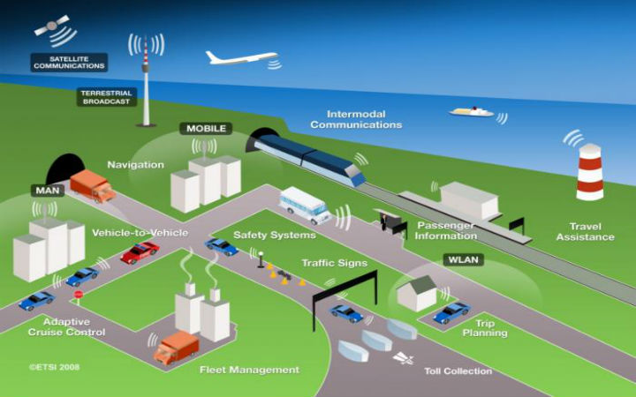  
**Fig 2.1 VANET-Overview**

2.3 **MAIN COMPONENTS**

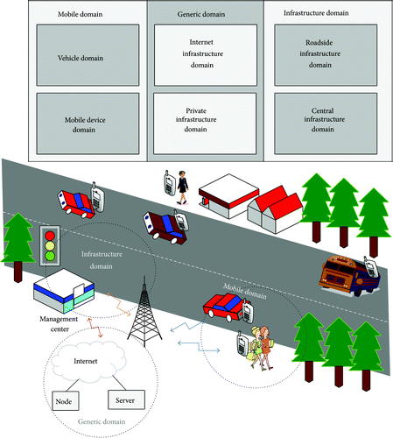

**Fig 2.2 Components of VANET**

According to the IEEE 1471-2000 and ISO/IEC 42010 architecture standard guidelines, we are able to achieve the VANETs system by entities which can be divided into three domains: the mobile domain, the infrastructure domain, and the generic domain.

The mobile domain consists of two parts: the vehicle domain and the mobile device domain. The vehicle domain comprises all kinds of vehicles such as cars and buses. The mobile device domain comprises all kinds of portable devices like personal navigation devices and smartphones.

Within the infrastructure domain, there are two domains: the roadside infrastructure domain and the central infrastructure domain. The roadside infrastructure domain contains roadside unit entities like traffic lights. The central infrastructure domain contains infrastructure management centres such as Traffic Management Centres (TMCs) and vehicle management centres.

However, the development of VANETs architecture varies from region to region. In the V2X communication system which is pursued by the V2V communication consortium, the reference architecture is a little different. V2V communication consortium is the major driving force for vehicular communication. This system architecture comprises three domains: in-vehicle, ad hoc, and infrastructure domain.

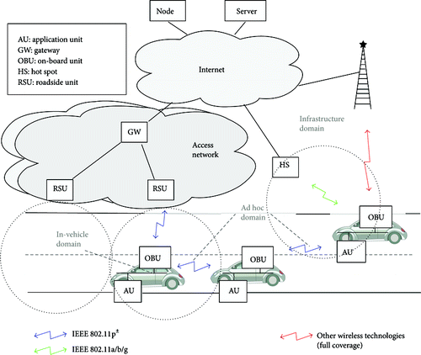

**Fig 2.3 VANET-Architecture**

The in-vehicle domain is composed of an on-board unit (OBU) and one or multiple application units (AUs). The connections between them are usually wired and sometimes wireless. However, the ad hoc domain is composed of vehicles equipped with OBUs and roadside units (RSUs). An OBU can be seen as a mobile node of an ad hoc network and RSU is a static node likewise. An RSU can be connected to the Internet via the gateway; RSUs can communicate with each other directly or via multi-hop as well. There are two types of infrastructure domain access, RSUs and hot spots (HSs). OBUs may communicate with Internet via RSUs or HSs. In the absence of RSUs and HSs, OBUs can also communicate with each other by using cellular radio networks (GSM, GPRS, UMTS, WiMAX, and 4G).

**2.4 COMMUNICATION ARCHITECTURE**

Communication types in VANETs can be categorized into four types. The category is closely related to VANETs components as described above.

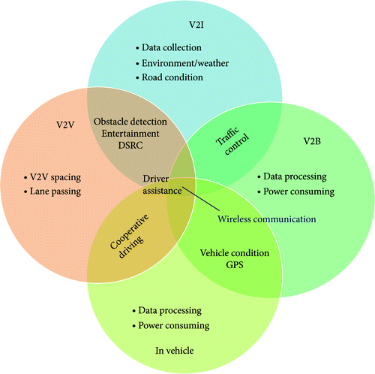

**Fig 2.4 VANET-Communication Architecture**

**In-vehicle communication**, which is more and more necessary and important in VANETs research, refers to the in-vehicle domain. In-vehicle communication system can detect a vehicle's performance and especially driver's fatigue and drowsiness, which is critical for driver and public safety.

**Vehicle-to-vehicle (V2V) communication** can provide a data exchange platform for the drivers to share information and warning messages, so as to expand driver assistance.

**Vehicle-to-road infrastructure (V2I) communication** is another useful research field in VANETs. V2I communication enables real-time traffic/weather updates for drivers and provides environmental sensing and monitoring.

**Vehicle-to-broadband cloud (V2B) communication** means that vehicles may communicate via wireless broadband mechanisms such as 3G/4G. As the broadband cloud may include more traffic information and monitoring data as well as infotainment, this type of communication will be useful for active driver assistance and vehicle tracking.

Generally, the architecture of VANETs may differ from region to region, and thus the protocols and interfaces are also different among them. DSRC is specifically designed for automotive use and a corresponding set of protocols and standards. The US FCC has allocated 75 MHz of spectrum for DSRC communication, from 5.850 GHz to 5.925 GHz. Different protocols are designed to use at the various layers; some of them are still under active development now. The IEEE 802.11p, an approved amendment to the IEEE 802.11 standard to add wireless access in vehicular environments (WAVE), is focused primarily on the PHY layer and MAC sublayer of the stack. IEEE 1609 is a higher layer standard based on the IEEE 802.11p. IEEE 1609 represents a family of standards that function in the middle layers of the protocol stack to flexibly support safety applications in VANETs, while non-safety applications are supported through another set of protocols. In particular, network layer services and transport layer services for non-safety applications are provided by three quite stable protocols: IPv6, TCP, and UDP.

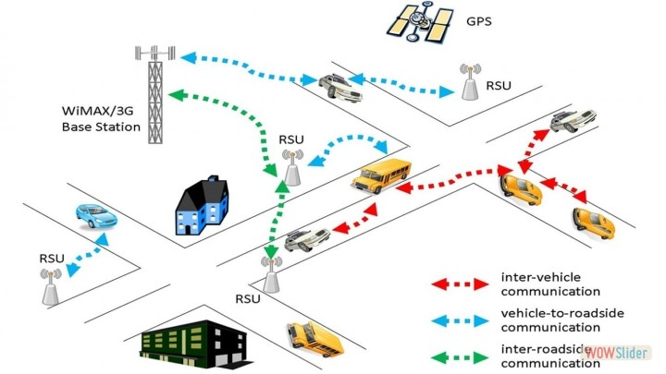

**Fig 2.5 Elements of VANET**

**2.5 ROUTING IN VANET**

For communication Ad-hoc networks are used. Ad-hoc Network is initially used for the MANETs but now they are used for the VANETs also. VANET utilizes these location based and topology-based steering conventions obliges that each of the partaking hubs be allocated a novel location. This intimates that we require an instrument that can be utilized to appoint interesting locations to vehicles yet these conventions don't promise that the copy locations are doled out in a system or not. Consequently, existing circulated tending to calculations utilized as a part of versatile specially appointed systems are significantly less suitable in a VANET environment. Particular VANET-related issues, for example, system topology, portability designs, thickness of vehicles at diverse times of the day, fast changes in vehicles arriving and leaving the VANET and the way that the width of the street is regularly littler than the transmission run all make the utilization of these routine specially appointed directing conventions lacking.

**Protective routing protocol:** Proactive steering conventions utilize standard separation vector directing methodologies (e.g., Destination-Sequenced Distance-Vector (DSDV) steering) or connection state directing techniques (e.g., Optimized Link State Routing convention (OLSR) and Topology Broadcast-focused around Reverse-Path Forwarding (TBRPF)). They keep up and overhaul data on directing to all hubs that being said additionally when the way is not utilized. Course overhauls are occasionally performed paying little heed to system load, data transmission imperatives, and system size.

**Reactive routing protocol**: Touchy directing conventions, for example, Dynamic Source Routing (DSR), and Ad hoc On-Demand Distance Vector (AODV) steering execute course determination on an interest or need premise and keep up just the courses that are right now being used, in this manner lessening the load on the system when just a subset of accessible courses is being used and this breaking point the data transfer capacity wastage.

**Position-based routing**: Position-based directing conventions oblige that data about the physical position of the taking part hubs be accessible. This position is made accessible to the immediate neighbours as intermittently transmitted reference points. A sender can ask for the position of a recipient with the assistance of an area administration.

**Forwarding:** A geographic uncast transports bundle between two hubs through various remote jumps. At the point when the asking for hub needs to send a unicast parcel, it discovers the position of the goal hub by taking a gander at the area table. An avaricious sending calculation is then used to send the bundle to the neighbouring vehicle or hubs, rehashes enumerating the base remaining separation to the end of the line vehicle and this methodology at each vehicle along the sending way until the parcel achieves its goal.

**2.6 AD-HOC ROUTING PROTOCOLS**

Wireless networks is an emerging new technology that will allow users to access information and services electronically, regardless of their geographic position. Wireless networks can be classified in two types: Infrastructured network and Infrastructure-less (**ad hoc**) networks. Infrastructured network consists of a network with fixed and wired gateways. A mobile host communicates with a bridge in the network (called base station) within its communication radius. The mobile unit can move geographically while it is communicating. When it goes out of range of one base station, it connects with new base station and starts communicating through it. This is called handoff. In this approach the base stations are fixed.

In contrast to infrastructure based networks, in ad hoc networks all nodes are mobile and can be connected dynamically in an arbitrary manner. All nodes of these networks behave as routers and take part in discovery and maintenance of routes to other nodes in the network. Ad hoc networks are very useful in emergency search-and-rescue operations, meetings or conventions in which persons wish to quickly share information, and data acquisition operations in inhospitable terrain.

Ad hoc routing protocols can be divided into two categories:

1. Table-driven
2. On-demand routing
3. Hybrid

based on when and how the routes are discovered. In table driven routing protocols, consistent and up-to-date routing information to all nodes is maintained at each node whereas in on-demand, routing the routes are created only when desired by the source host. Next two sections discuss current table-driven protocols as well as on-demand protocols.

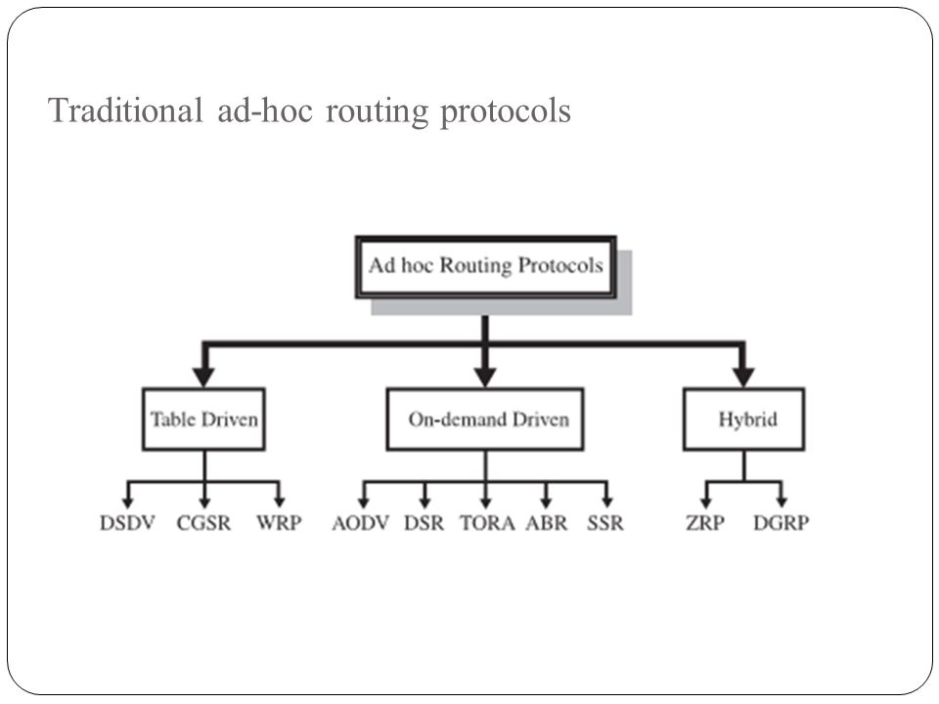  
**Fig 2.6 Ad hoc Protocols**

**2.6.1 TABLE DRIVEN ROUTING PROTOCOLS – PROACTIVE**

In Table-driven routing protocols each node maintains one or more tables containing routing information to every other node in the network. All nodes update these tables so as to maintain a consistent and up-to-date view of the network. When the network topology changes the nodes propagate update messages throughout the network in order to maintain a consistent and up-to-date routing information about the whole network. These routing protocols differ in the method by which the topology change information is distributed across the network and the number of necessary routing-related tables. The following sections discuss some of the existing table-driven ad hoc routing protocols.

## **Destination-Sequenced Distance-Vector Routing Protocol:**

The Destination-Sequenced Distance-Vector (DSDV) Routing Algorithm is based on the idea of the classical Bellman-Ford Routing Algorithm with certain improvements.

Every mobile station maintains a routing table that lists all available destinations, the number of hops to reach the destination and the sequence number assigned by the destination node. The sequence number is used to distinguish stale routes from new ones and thus avoid the formation of loops. The stations periodically transmit their routing tables to their immediate neighbours. A station also transmits its routing table if a significant change has occurred in its table from the last update sent. So, the update is both time-driven and event-driven. The routing table updates can be sent in two ways: a "full dump" or an incremental update. A full dump sends the full routing table to the neighbours and could span many packets whereas in an incremental update only those entries from the routing table are sent that has a metric change since the last update and it must fit in a packet. If there is space in the incremental update packet then those entries may be included whose sequence number has changed. When the network is relatively stable, incremental updates are sent to avoid extra traffic and full dump are relatively infrequent. In a fast-changing network, incremental packets can grow big so full dumps will be more frequent. Each route update packet, in addition to the routing table information, also contains a unique sequence number assigned by the transmitter. The route labelled with the highest (i.e. most recent) sequence number is used. If two routes have the same sequence number then the route with the best metric (i.e. shortest route) is used. Based on the past history, the stations estimate the settling time of routes. The stations delay the transmission of a routing update by settling time so as to eliminate those updates that would occur if a better route were found very soon.

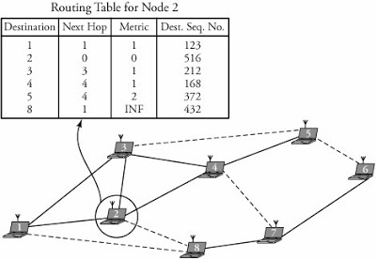

**Fig 2.7 DSDV Routing**

# 2.6.2 ON-DEMAND ROUTING PROTOCOLS – REACTIVE

These protocols take a lazy approach to routing. In contrast to table-driven routing protocols all up-to-date routes are not maintained at every node, instead the routes are created as and when required. When a source wants to send to a destination, it invokes the route discovery mechanisms to find the path to the destination. The route remains valid till the destination is reachable or until the route is no longer needed.

**AODV ROUTING**:

AODV is a well-known topology routing protocol which has a very high packet delivery ratio and low routing overhead. AODV works as follows:

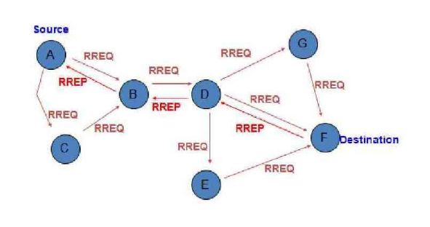

**Fig 2.8 AODV Routing**

Whenever a node wants to communicate with another node, it checks in local routing table to find an available path to the destination node. If there is no path available, then it broadcasts a route request (RREQ) message to its neighbourhood. The node that receives RREQ looks its table for a path leading to the destination node. If there is no path then, the RREQ message is re-broadcasted and a path to the originating node is formed that has sent RREQ message. This helps in establishing the end to end path when the same node receives route reply (RREP) message as shown in Figure.

All the node in the network follows this process until this RREQ message reaches a node which has a suitable path to the destination Node. At the end of this request-reply process a path between source and destination node is created and is available for further communication. In this way, the originating node that generated RREQ receives an RREP message.

To maintain a connection with the sink node is a crucial issue to collect data from networks without any interruption. While networks are typically deployed in abundance, losing the connectivity with the sink node due to frequent path break eventually reduces the quality and efficiency of the network operation.

**2.6.3 HYBRID (BOTH PROACTIVE AND REACTIVE)**

This type of protocol combines the advantages of proactive and reactive routing. The routing is initially established with some proactively prospected routes and then serves the demand from additionally activated nodes through reactive flooding. The choice of one or the other method requires predetermination for typical cases. The main disadvantages of such algorithms are:

1. Advantage depends on number of other nodes activated.
2. Reaction to traffic demand depends on gradient of traffic volume.

**2.6.4 COMPARISON OF AODV AND DSDV**

Following review of two protocols - AODV and DSDV

1. Both protocol used the concept of sequence number to update latest routing information.
2. The bandwidth is wasted in case of DSDV, because of periodic broadcasting of updated information. In AODV, nodes only propagates hello messages to its neighbours.
3. In DSDV, routes information which are maintained in routing table can be stale as DSDV cannot handle nodes movement at high speeds due to lack of alternative routes. But in case of AODV, the routes are find out on demand only, so the routes information cannot be stale.
4. In DSDV, throughput decreases because of periodic routes information updates and if the node mobility is at high speed. In AODV, throughput is stable because it don’t broadcast any routing information.

Also, the End-to-End delay is calculated for both DSDV and AODV routing protocols.

**End to End Delay:** The average time from the beginning of a packet transmission at a source node until packet delivery to a destination. This includes delays caused by buffering of data packets during route discovery, queuing at the interface queue, retransmission delays at the MAC, and propagation and transfer times.

On Calculating E2E for both DSDV and AODV, it is found that AODV betters DSDV, having lower delay.

Since, DSDV dynamically checks for the shortest path at every instant even when the established route exists, the delay is higher and also thereby throughput is less.

While AODV protocol uses an already established route until the nodes move out of range. Hence the delay is lower and throughput is high.

**Fig 2.9 AODV vs DSDV**

From the Analysis, it is found that AODV protocol provides a lower delay in every case. Since the delay is lower, more number of packets can be communicated between the nodes and thereby throughput is higher.

Throughput = (Received Data Size/Transmission Time)*8

Hence in our project, which requires a demanding routing protocol with high throughput and lower delay as vehicles keep moving at high speeds, AODV is more preferred and used for Vehicular communication.

**CHAPTER – 3**

**WORKING OF VANET**

**3.1 INTELLIGENT TRANSPORTATION SYSTEM**

Each vehicle participates as a sender, receiver and router to transmit information to the vehicular network or the agency, than it uses the information for safety and free flow of traffic. ITS explains technology relevant to transport and infrastructure, transferring information within systems to increase safety, productivity and environmental performance. Standalone application ex. traffic management system and information participate in it and they installed in vehicles. ITS encompasses large range of wire line and wireless communication depending information and electronic technologies.

**3.1.1 VEHICLE TO VEHICLE COMMUNICATION**

V2V communication composed a wireless network in which automobiles can transfer information with each one, such as safety warning and traffic information. The data or information about what they are doing contains of location, speed, travelling, direction, stability loss and braking. V2V uses a standard known as Dedicated short range communication (DSRC). For sometimes it can be explained as a Wi-Fi network, the reason is frequency is 5.9 GHz (used by Wi-Fi) band with bandwidth of 75 MHz, so we can say that it behaves more like Wi-Fi. Range is about 1000 feet (300 meters) which is on highway about 10 sec. In V2V every node can send, catch or transmit again the signals, we can say it become a mesh network. For vehicular network there are two standard division which include a class of IEEE called IEEE 802.11 which is Wireless Access in Vehicular Environments (WAVE). For 802.11 wireless LAN, MAC layer and PHY layer there is an enlargement known as 802.11p. The main role of 802.11p is to support specification for PHY and MAC layer for vehicular network.

**3.1.2 VEHICLE TO INFRASTRUCTURE COMMUNICATION**

The motivation of infrastructure in V2I is that by meeting global and local information of the traffic related to road state than create their protocol with the group of vehicles. V2I is the wireless exchange of critical safety and data between vehicles and infrastructure on highway. It represents a one way hop where on road unit send information to all vehicles. With the aim of elaboration of all the fuel consumption, emissions the acceleration and the velocities of the vehicles and the inter vehicle distance would suggests by the infrastructure which is based on the traffic conditions. Information to drivers are broadcast through the road display or wireless connections directly. The roadside units placing at every kilometre, taking high data rates which should be maintained for heavy traffic. For such an instance when broadcasting dynamic limits the infrastructure unit will examine the approximate speed according to its inner traffic conditions. The unit will broadcast a message at particular interval of time which can take the limit of speed and compare the directional limits with the vehicle.

The rules define for the operations in VANET which are as: Dense traffic, sparse traffic & Regular traffic. For the three rules one thing should take in mind that a good and efficient routing protocol dealt with it.

**Dense traffic:** When the density of the traffic is above the level than the most common problem is that there is a choking of the shared medium by controlled number of safety message which are broadcast by various cars following each other continuously. Therefore the result is confliction in the transmission of the data within the neighbouring nodes because of the negligent broadcast of the packets through the shared wireless channel. Normally this situation is known as broadcast storm problem.

**Sparse traffic:** Another traffic which is creating difficulty for the standard routing protocols is the sparse traffic in which there are least number of vehicles participating on the road. At some amount of time on day the traffic must become slow that multiple hoc coming from the source to the car may not be probable because they are not in the range of the transmission area of the source. On the opposite lane there might be no cars in the transmission range this situation make it more worse so this type of situation creates problems for routing and broadcasting, there are various techniques available for this situation which address the sparsely joined behaviour of the mobile wireless network.

**Regular traffic:** The dense and the sparse traffics which we have talked about have one thing is likewise that the global connectivity is effected by the local connectivity in the networks of the vehicles such as take an examples of as in a busy network the vehicle notice the closely local topology and in sparse network vehicles observe very less or no neighbours or we can say that sparse topology. Therefore vehicles working in these two rules will observe the same local topology which should directly effect the global topology. As far this situation creates the vehicles will apply the algorithm which is known as broadcast suppression and to conserve network operability some vehicles will follow the save carry forward message

**3.2 METHODOLOGY**

**Phase 1:** In this phase VANET scenario is initialize by defining are of simulation no. of vehicle in direction reverse direction their mobility.

**Phase 2:** In this phase various communications between different vehicles and roadside unit will take place using the routing protocol for the communication process.

**Phase 3:** In this phase cognitive radio bandwidth has been utilized for the transmission of packets from vehicle to vehicle and vehicle to RSU and RSU to vehicle by sensing channel. The channel is free that can be allocated for communication.

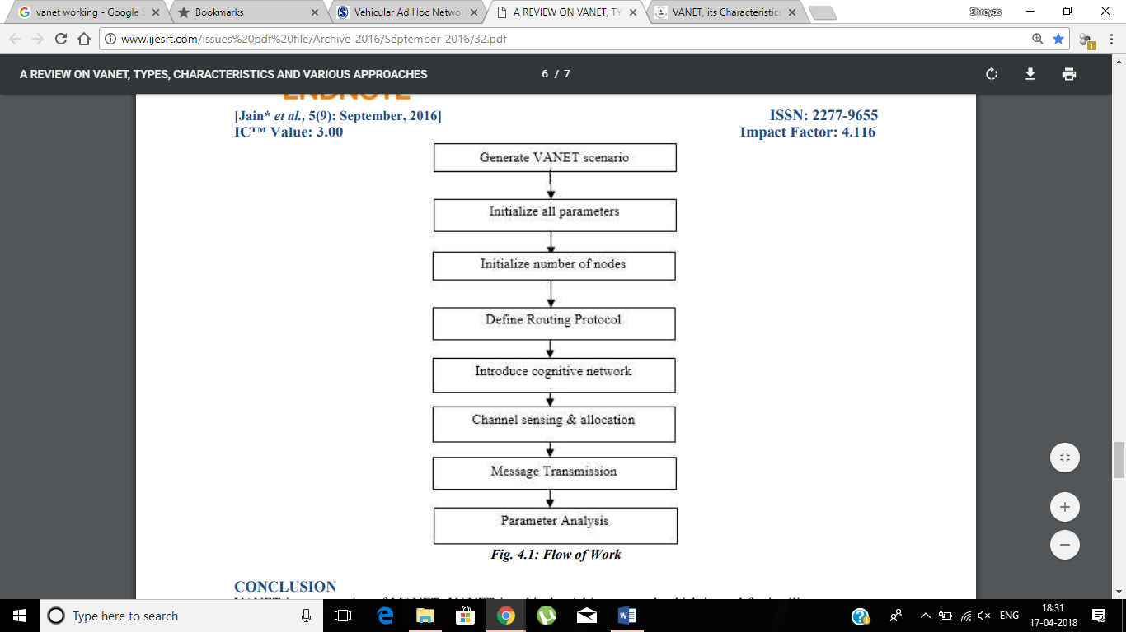  
**Fig 3.1 VANET Methodology**

**3.3 PROPOSED SYSTEM MODEL**

A complete VANET system model is established with Vehicles as Mobile Nodes and RSUs as stationary nodes. RSUs are some base stations which broadcast the message alerts to every node in its range. RSUs are assumed to be always connected with each other through a gateway. Also all the RSUs are maintained at a central data centre.

RSUs receive data packets from:

1. Central Traffic Management Centre
2. Other RSUs
3. Moving Vehicles

RSU maintains a database of the number of vehicles in its area, emergency message alerts it received from TMC/Vehicles and the data to be broadcasted. The RSU then broadcasts the data packets to the nearby vehicles which reach the destination directly or through ad hoc.

For example, in case of an accident occurred in a region, the RSU receives the alert message from that vehicle and it transfers this alert to nearby RSUs which in-turn broadcasts the message to the vehicles which are actually far-away from the area where the accident occurred. This provides an opportunity to these vehicles to take an alternate route in order to avoid the accident zone where roads may have got blocked or a high density of traffic congestion could have occurred.

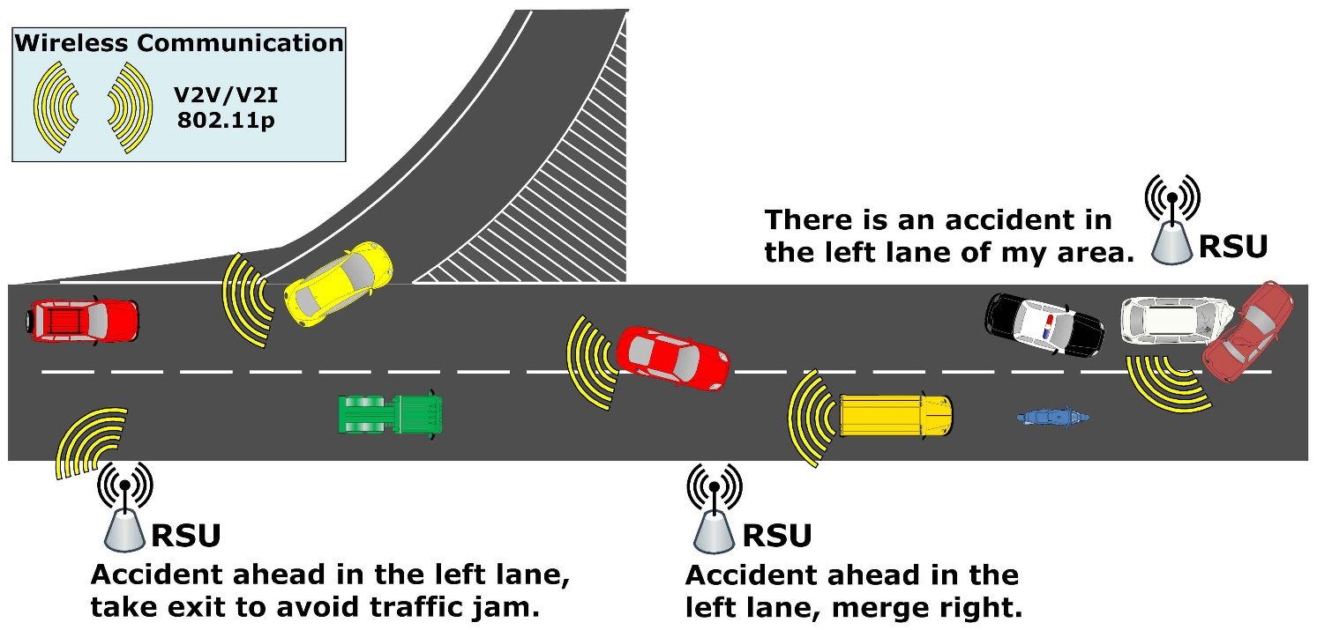  
**Fig 3.2 VANET Model**

Also, the occurrence of accident could be forwarded to an Ambulance/Police vehicle via other vehicles/RSUs or even from the TMC in case of no emergency vehicle in nearby area. Thus, quick recovery of normal traffic scenario can be restored and much waste of time could be avoided.

Also, in our model, every vehicle communicates with each other by broadcasting messages. This could prove very useful in case of extreme weather conditions where even the visibility of nearby vehicles could be difficult and also in case of sharp turnings or road damage.

Thus, three communication scenarios are used:

1. V2V – Vehicle to Vehicle
2. V2I – Vehicle to Infrastructure
3. I2I – Infrastructure to Infrastructure

By using this combination of communication, maximum interconnectivity can be achieved in the VANET scenario and data packets can be transferred to every vehicle in the network.

**CHAPTER - 4**

**VANET FOR BOATS**

**4.1 INTRODUCTION**

We extended this idea of VANET to a common problem of fishermen communication. The idea is to use an inter boat communication.

Presently fishermen in most parts of the world has no way of contacting the people in the shore in case of any emergency or in case of dangerous weather forecast when they are deep into the sea for fishing. There are many deaths or many missing cases of fishermen due to bad weather. If the fishermen are alerted of the weather forecasts earlier, they could return or at least take safety measure required. Also by establishing boat-boat communication, they can save each other in case of emergencies and can also report to the base station at the shore. Using this model, we can give a warning message to the fishermen from the shoreand the other way too.

**4.2 CHARACTERISTICS**

1. BSIs-Buoys installed at required locations
2. B2B communication via BSIs
3. Satellite connection
4. Communication of alerts in emergencies
5. Alerts at international borders

**4.3 PRESENT COMMUNICATION IN BOATS:**

At present, some boats have one way satellite communication and mostly ships might have two way satellite communication but majority don’t have any type of communication with the shore. But they are able to communicate within the boats which are in LOS using VHF/UHF data radios**.** LOS propagation over water can be a serious problem because of multipath reflection of the radio signal off the water. Also, no model is present for the fishermen to communicate with the shore.

**4.4 PROPOSED SYSTEM**

With the system we propose we will able to communicate boats within **100km** range of BSI we are going to keep and these BSI will communicate to the shore via satellites**.** The frequency range we would use is 2 to 5 MHz and modulation would be selected based on the bits per rate for example 3200bps could be given using QPSK or 9600bps using 16-QAM.

4.5 **ARCHITECHTURE**

**Fig 4.1 VANET for Boats - Architecture**

Satellite

Ships / Coast Guard

Boats

BSIs

Base Station at Land

**4.5.1 BASE STATION AT LAND**

This is from where we send a warning message. It could be the meteorological centre or any other data centre.

**4.5.2 BOAT SIDE INFRASTRUCTURE (BSI)**

**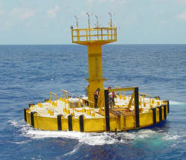 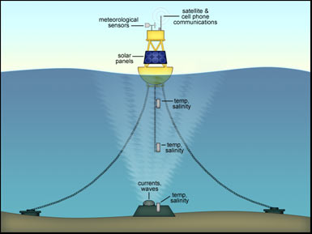  
Fig 4.2 Boat Side Infrastrcutre - Buoy**

The infrastructure we plan to use are buoys which are used in the sea. Buoys are presently used for meteorological purpose, to measure depth of sea, to warn boats of rocks ahead or to measure seismic activities at the sea. The measurements monitored are reported to the land via satellite. But, in our model, we will use these buoys for communication purposes too. Base stations at the land communicate with boats through these buoys. These buoys will have a range which varies based on the transceiver on it. Figure-1 is a Large Navigational Buoy which is about 12m high and Figure-2 is how a meteorological buoy or any other buoys are attached to a place in the sea. Solar energy and battery would be used to power the buoy.

**CHAPTER - 5**

**SIMULATION & RESULTS**

**5.1 SOFTWARE USED**

Two main software are used for simulating the VANET scenario. While the first software is used to design and develop a traffic model for vehicles to commute, the second enables communication between the nodes established.

**5.1.1 SUMO – SIMULATION OF URBAN MOBILITY**

SUMO or simulation of urban mobility is an open source, highly portable, microscopic and continuous road traffic simulation package designed to handle large road networks. It is mainly developed by employees of the Institute of Transportation system at German aerospace Centre. SUMO is open source, licensed under the GPL.

**5.1.2 NS2 – NETWORK SIMULATOR**

Ns is a discrete event simulator targeted at networking research. Ns provides substantial support for simulation of TCP, routing, and multicast protocols over wired and wireless (local and satellite) networks.

Ns is built using [C++](https://en.wikipedia.org/wiki/C%2B%2B) and [Python](https://en.wikipedia.org/wiki/Python_(programming_language)) with scripting capability. The ns library is wrapped by Python thanks to the pybindgen library which delegates the parsing of the ns C++ headers to gccxml and pygccxml to automatically generate the corresponding C++ binding glue. These automatically-generated C++ files are finally compiled into the ns Python module to allow users to interact with the C++ ns models and core through Python scripts. The ns simulator features an integrated attribute-based system to manage default and per-instance values for simulation parameters.

NS2 stands for Network Simulator Version 2. It is an open-source event-driven simulator designed specifically for research in computer communication networks.

**5.2 MODELLING**

Simulation of VANET scenario is done in 2 parts, namely:

1. Traffic Model
2. Communication Model

**5.2.1 TRAFFIC MODEL**

In Traffic modelling, the paths are designed and routes are established for the movement of vehicles. The simulation is first tried in manual by manually creating nodes and paths for roads and routes are entered using lines of code. Further, upon the checking of this simulation, it is then extended for real-time traffic in which a real-time map is established with paths and random movements are provided to the vehicles and simulated.

**5.2.2 COMMUNICATION MODEL**

Once the Traffic model is established, the next step is to enable communication between nodes for VANET scenario. For simulation purposes, the communication model for manually established nodes is first simulated and analysed for their performance. Routing models are simulated and the protocol which is found to be most suited is selected for real-time simulation. Once, the manual simulations are done and analysed for optimal performance, the communication model is established for the real-time traffic simulated. The performance of VANET scenario is determined and results are published.

Various Simulations executed are as follows:

**Traffic Model:**

1. Manual Traffic Simulation using SUMO
2. Real-time Traffic Simulation using SUMO

**Communication Model:**

1. Simulation for V2V communication using manually established mobile nodes using Ns2.
2. Simulation for I2I communication using manually established stationary nodes using Ns2.
3. Simulation of complete VANET scenario using manually established mobile and stationary nodes using Ns2.
4. Simulation of complete real-time VANET scenarios using the real-time traffic models derived from SUMO software. The real-time traffic models are simulated as follows:
   1. Regular Traffic
      1. Densely populated area:
         1. Kathipara
         2. T.Nagar
      2. Sparsely populated area:
         1. Rural - Village
   2. Irregular Traffic
      * 1. Highway

**5.3 TRAFFIC MODELLING - MANUAL ROAD DESIGNING**

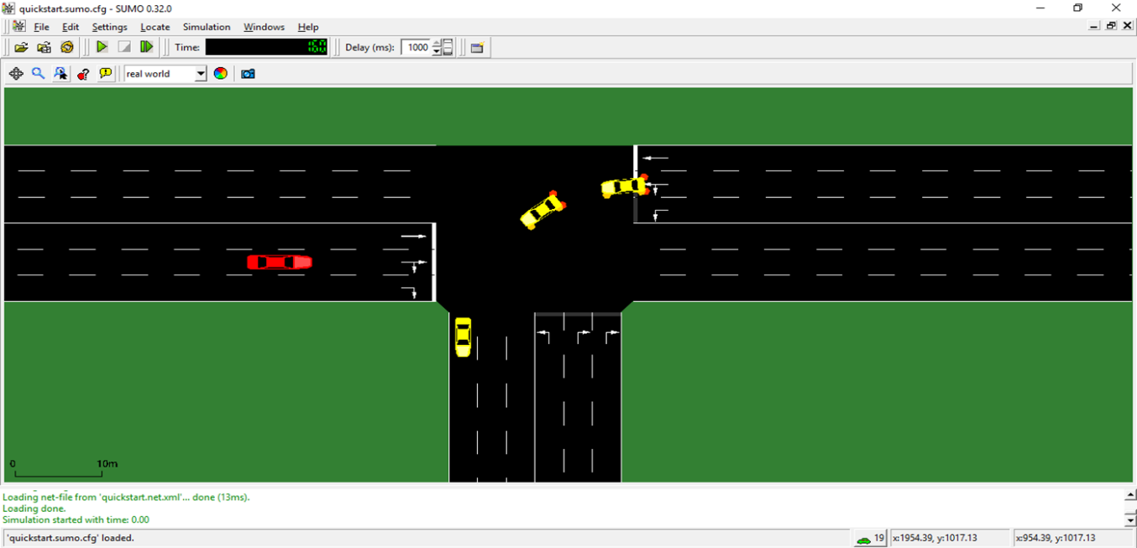 Before trying out in real time scenarios. It is important to check the credibility of SUMO. So we tried out SUMO by enabling it by manually designing the roads, vehicles, delay time and various polygons.

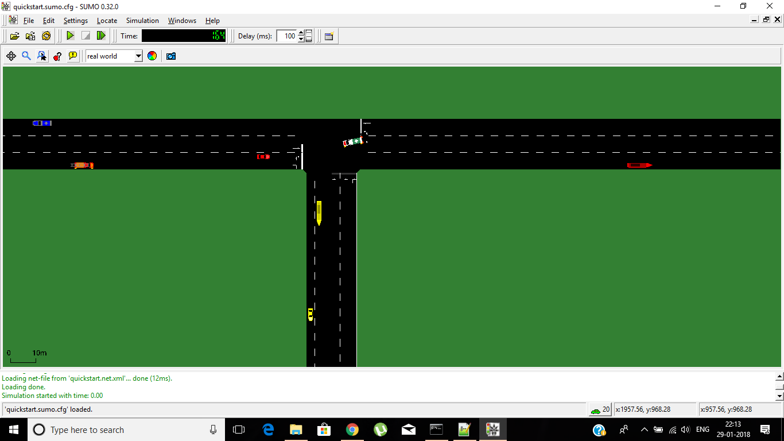

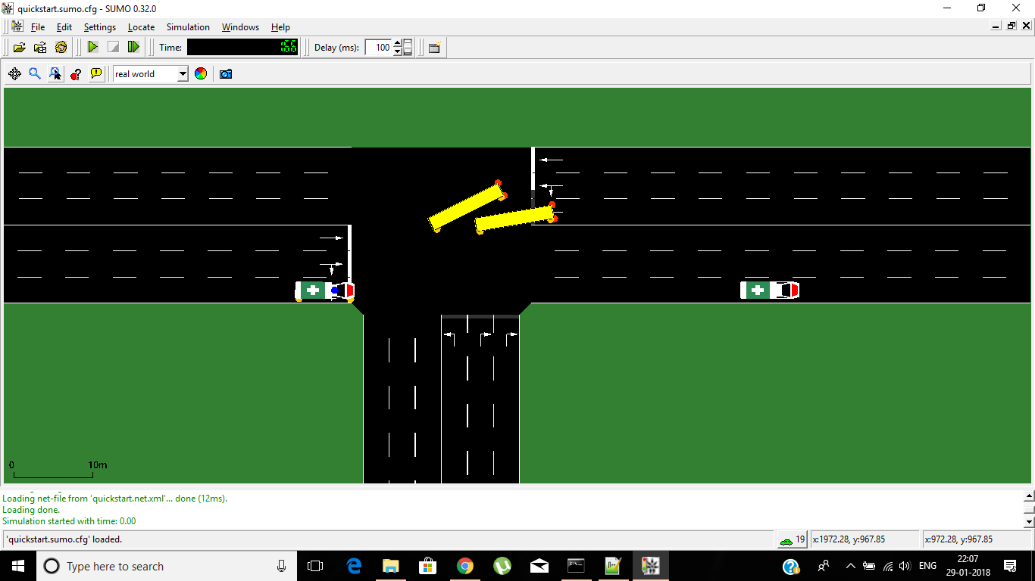  
**Fig 5.1 Simulation of Traffic Model**

We also tried to add various vehicles like cars, ambulances, buses, police vans, trucks and we analysed their mobility by adding routes to each vehicle in sumo. We also modified the lanes and observed the working.

**5.4 TRAFFIC MODELLING - REAL-TIME MAP DESIGNING**

Steps followed:

1. Download the OSM file from [www.openstreetmap.org](http://www.openstreetmap.org/) – “map.osm”
2. Open the terminal in the required work directory
3. Command: **netconvert --osm-files map.osm -o map.net.xml**

The osm file is then into a xml file and thereby the roads and paths are created as a network.

1. Command: **polyconvert --osm-files map.osm --net-file map.net.xml --type-file osmPolyconvert.typ.xml -o map.poly.xml**

Using the osm file and network file every object in the network is converted in the form of polygons for a 2D view.

1. Command: **python randomTrips.py -n map.net.xml -r map.rou.xml -e 50 –l**

Random route trips are generated for a required number of vehicles.

1. Finally, the files created are incorporated as a configuration file which is the mother file used for simulation – “map.sumo.cfg”

All the required network, polygon, route files are provided as child files inside the configuration file.

1. The simulation can then be run in ‘GUI’ format by typing,

Command: **sumo-gui map.sumo.cfg**

**5.4.1 THE KATHIPARA SCENARIO**

We simulated SUMO using real time scenario of Kathipara. Area of Kathipara experiences moderate traffic round the clock. We have specified the number of vehicles and analysed the traffic in the area.

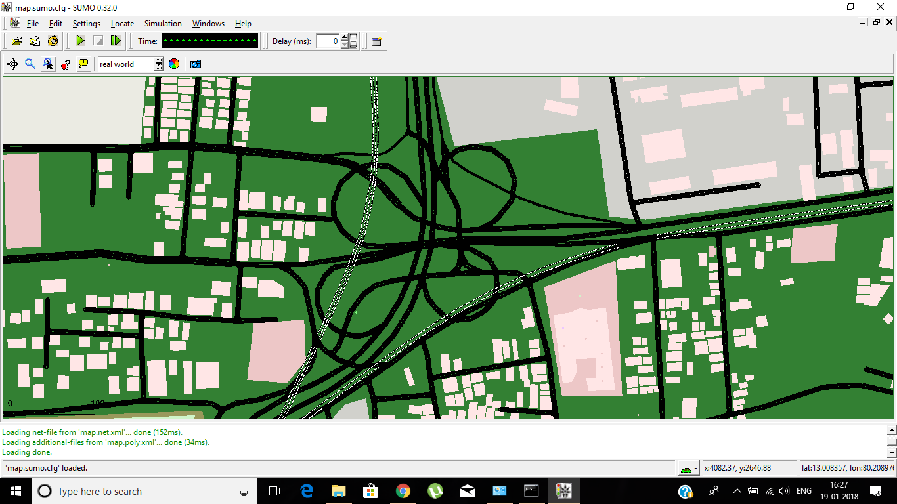

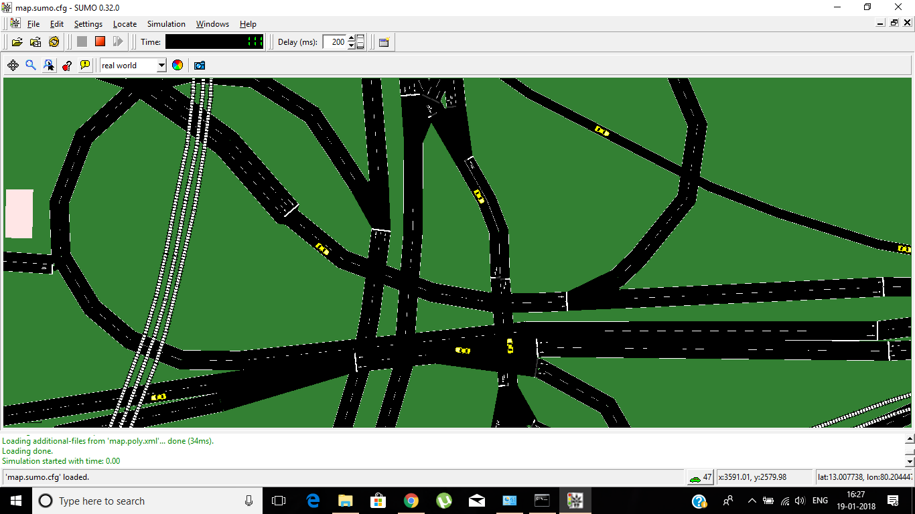**Fig 5.2 Real time simulation - Kathipara**

**5.4.2 T.NAGAR SCENARIO**

After analysing the mobility of moderate traffic areas like Kathipara, we also analysed an area where the roads are highly populated with vehicles for most of the time, like T Nagar which is considered as the Times Square of India.

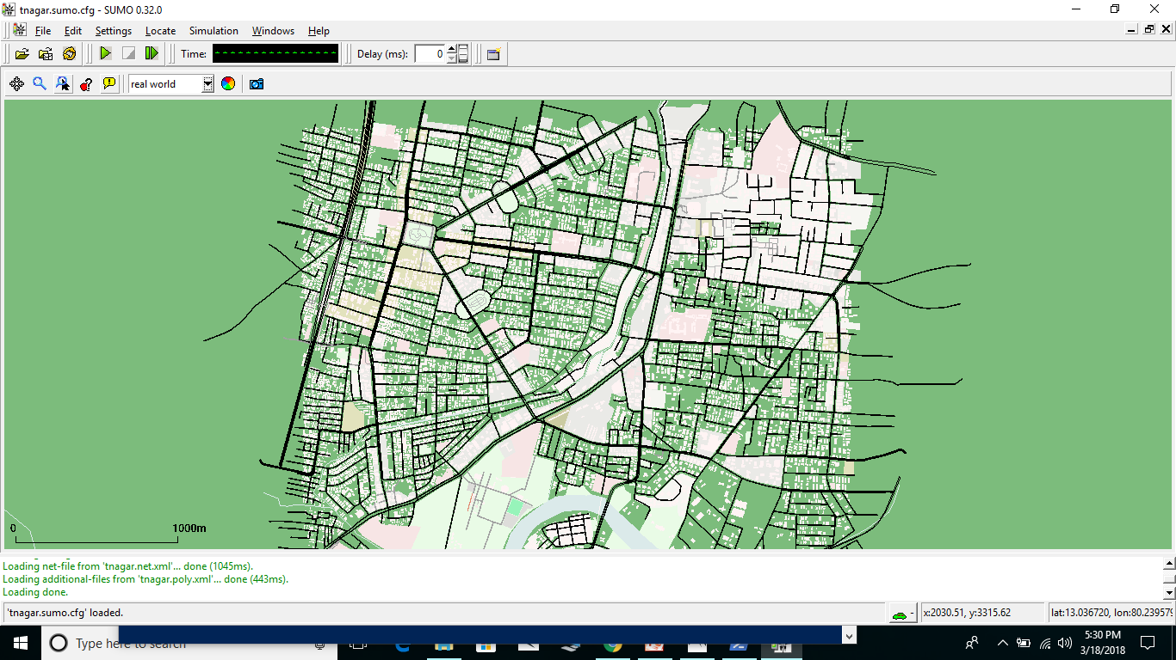

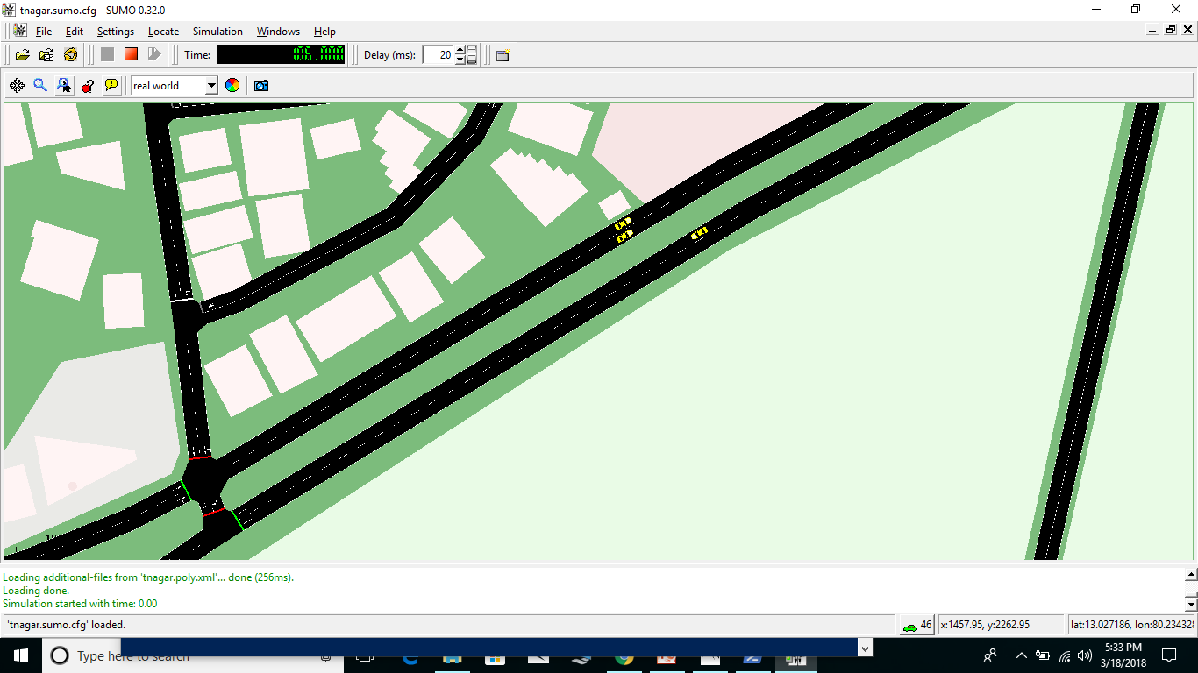  
**Fig 5.3 Real time Simulation – T Nagar**

**5.4.3 VILLAGE SCENARIO**

**68.84%** of Indian population reside in villages. Therefore this project would be incomplete without village scenario assessment. The roads are very much under-developed in rural areas and also the number of vehicles here are significantly lower than those in urban areas.

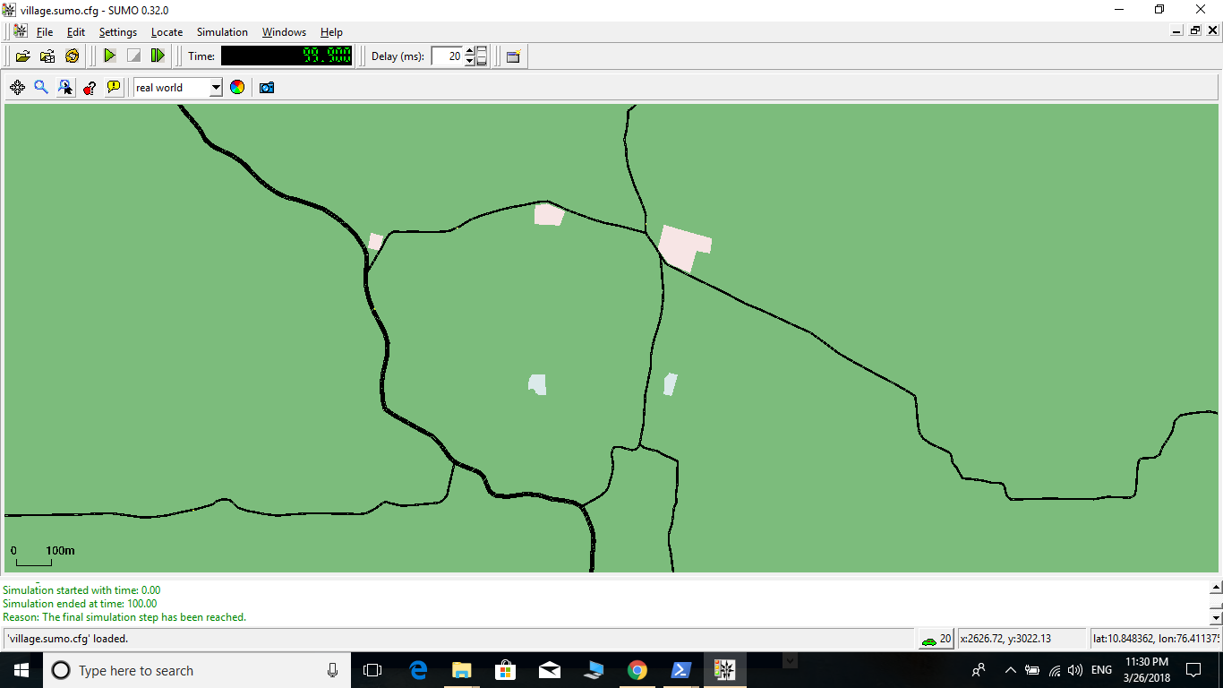  
**Fig 5.4 Real time Simulation - Village**

**5.4.4 HIGHWAY SCENARIO**

**India has 228 highways in total.** Hence, VANET modelling for highway is indispensable in our project. But, the modelling of a highway differs from the previous ones as the traffic is irregular in Highways. The traffic can vary from a dense population during weekends to very low population of vehicles and the prediction becomes very difficult.

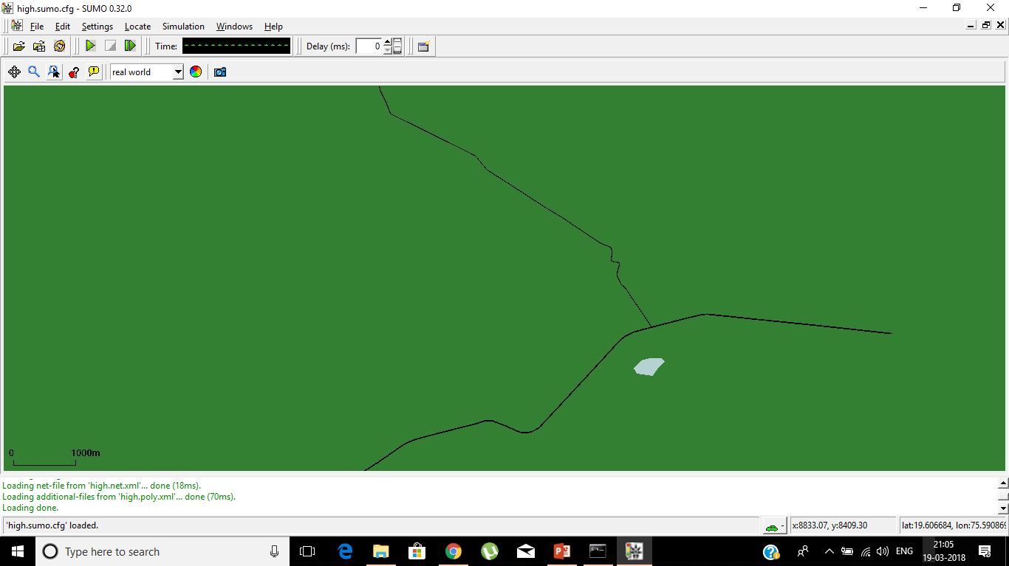

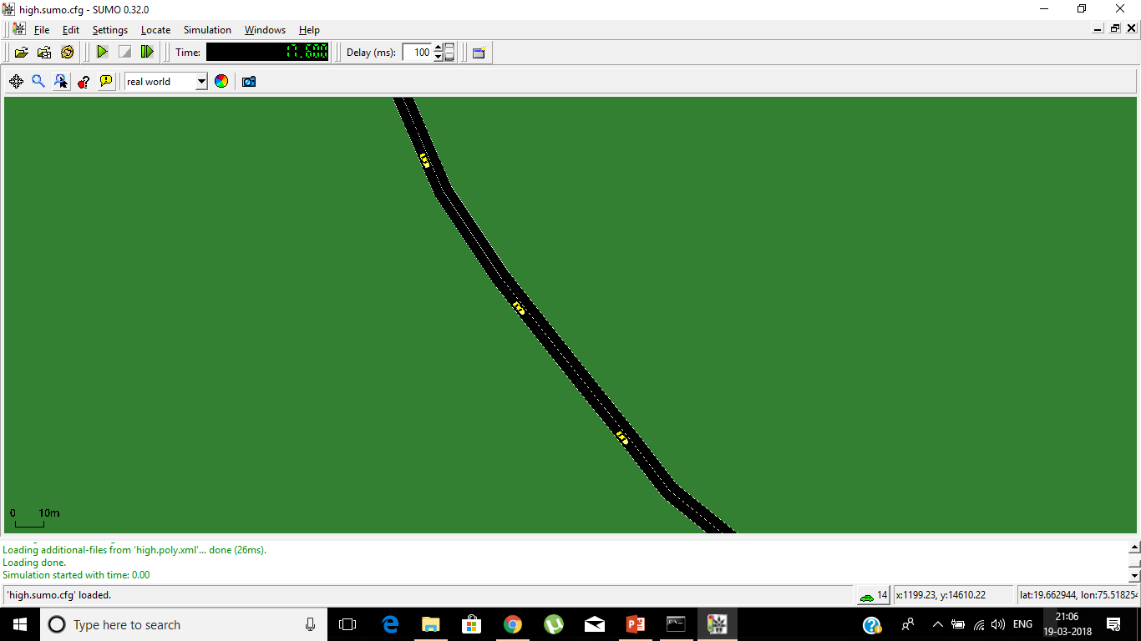  
**Fig 5.5 Real Time Simulation - Highway**

Thus the traffic models are designed and simulated for various scenarios using SUMO. Once the traffic simulations are analysed, the next step is to establish communication between nodes.

**5.5 COMMUNICATION MODEL**

Ns2 is used to simulate communication models. Before trying out the real-time scenario, it is necessary to check the performance of various communication models such as I2I, V2V, V2I in order to confirm for optimal results. Also, the wireless scenario using AODV protocol needs to be analysed and confirmed that it could yield fruitful results in real-time.

**5.5.1 AODV ANALYSIS**

Ad hoc On Demand Distance Vector (AODV) protocol is analysed for various scenarios.

For example, consider 5 nodes:

1. Communication is first established where only one node acts as a sender while other nodes act as receivers/routers. Then the scenario is extended with two nodes sending data and then three nodes and so on.
2. Also, a scenario is checked where the duration of nodes being in range differs. Such that when the sender and receiver are in range for the entire duration, when they are in range for a lower duration and even lower duration and so on.

The Packet Delivery Ratio and Average End-to-End delay are calculated for every model:

Packet Delivery Ratio = (Received data/Sent Data)*100

End-to-End Delay = (Stop Time – Start Time)

**Start Time:**

Time at which the packets are generated and sent by the sender

**Stop Time:**

Time at which the communication gets complete and the packets gets received at the receiver.

Average End-to-End Delay = (End-to-End Delay)/Number of transmissions

**Fig 5.6 AODV Analysis 1**

It is found that the Packet Delivery Ratio is above 90% for every model and hence the performance is optimal.

**Fig 5.7 AODV Analysis 2**

It is found that the number of packets sent and received continuously decreases, though the PDR remains above 90%. This is because as the nodes move out of range, communication gets cut and packets need to find an alternate route. Also when no route is available, the communication is completely halted and enters a wait state and is resumed whenever a route to the destination is found. Hence, in order to prevent larger duration of being in wait state, the need of RSUs occur.

**5.5.2 RSU-RSU COMMUNICATION**

In VANET scenario, RSUs are assumed to be always connected through some gateway. They are interconnected with each other and also with the Central TMC. Here, the simulation of RSU-TMC-RSU is first executed and communication is enabled.

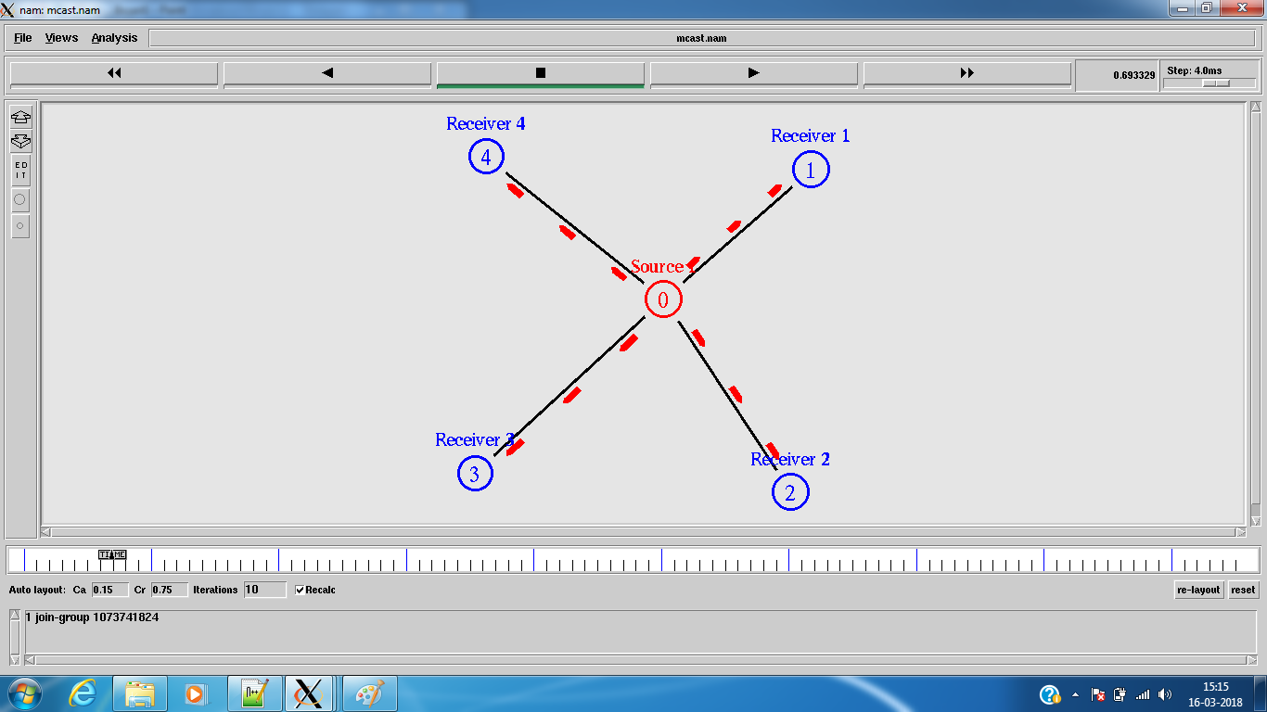

**Fig 5.8 RSU-TMC-RSU communication**

Source – Central Server ; Receivers 1,2,3,4 – RSU

The central server maintains the complete database of the traffic conditions and broadcasts messages to RSUs at regular intervals. The RSUs too report the traffic information in its range of communication to the TMC which thereby updates its database.

**5.5.3 VEHICLE-TO-VEHICLE COMMUNICATION**

Next, the V2V scenario is simulated individually using the AODV protocol and analysed. Wireless scenarios are designed for various number of mobile nodes where every node acts as a sender, receiver and a router. The nodes are established manually and movements occur at random instants in a random manner.

**Scenario 1:**

V2V communication is first checked for different number of nodes, but with only 5 nodes actually communicating while the other nodes act as routers.

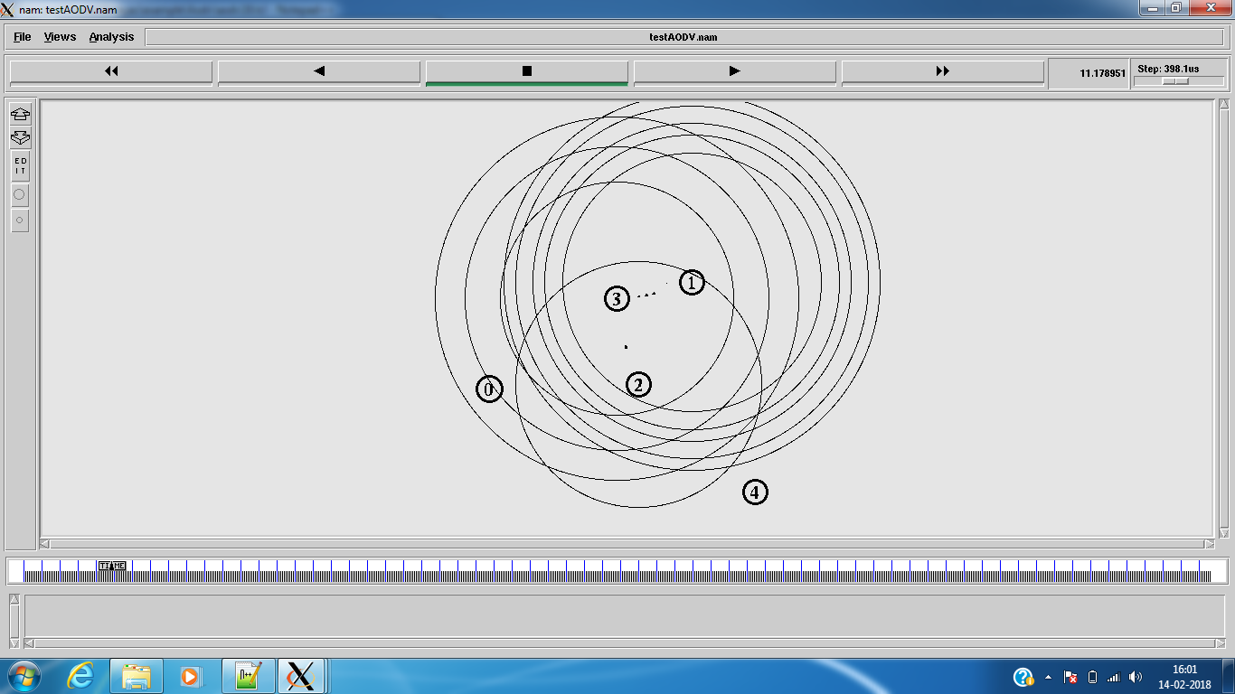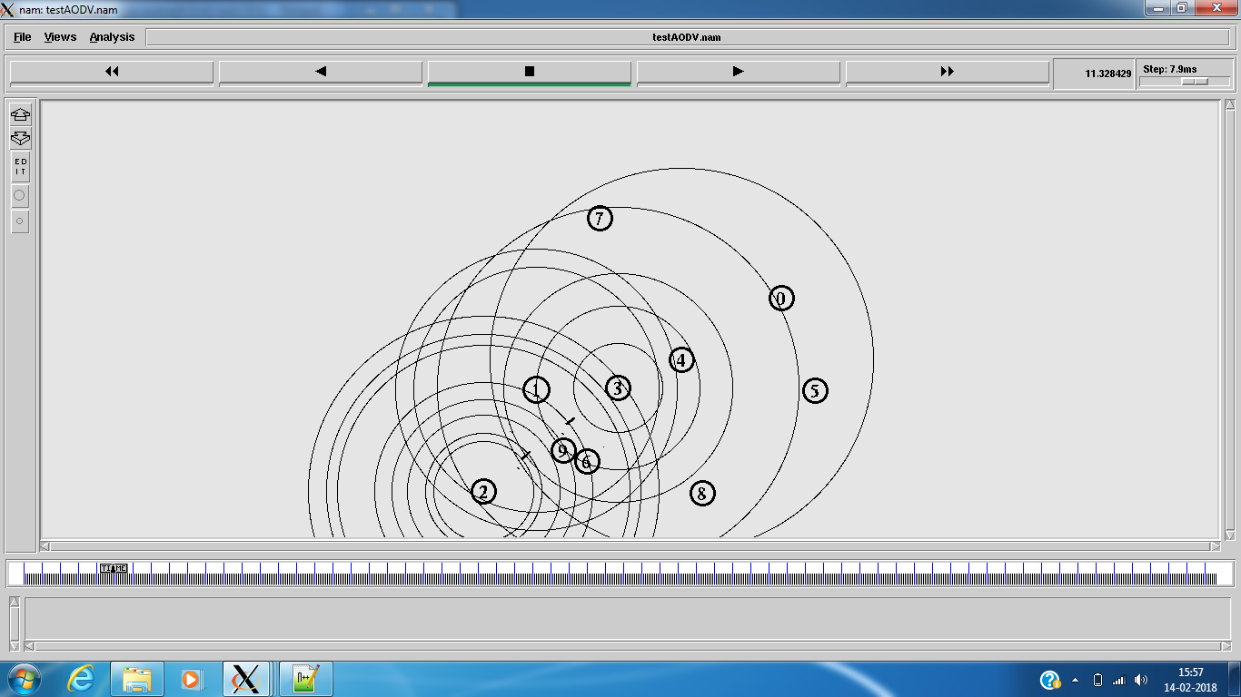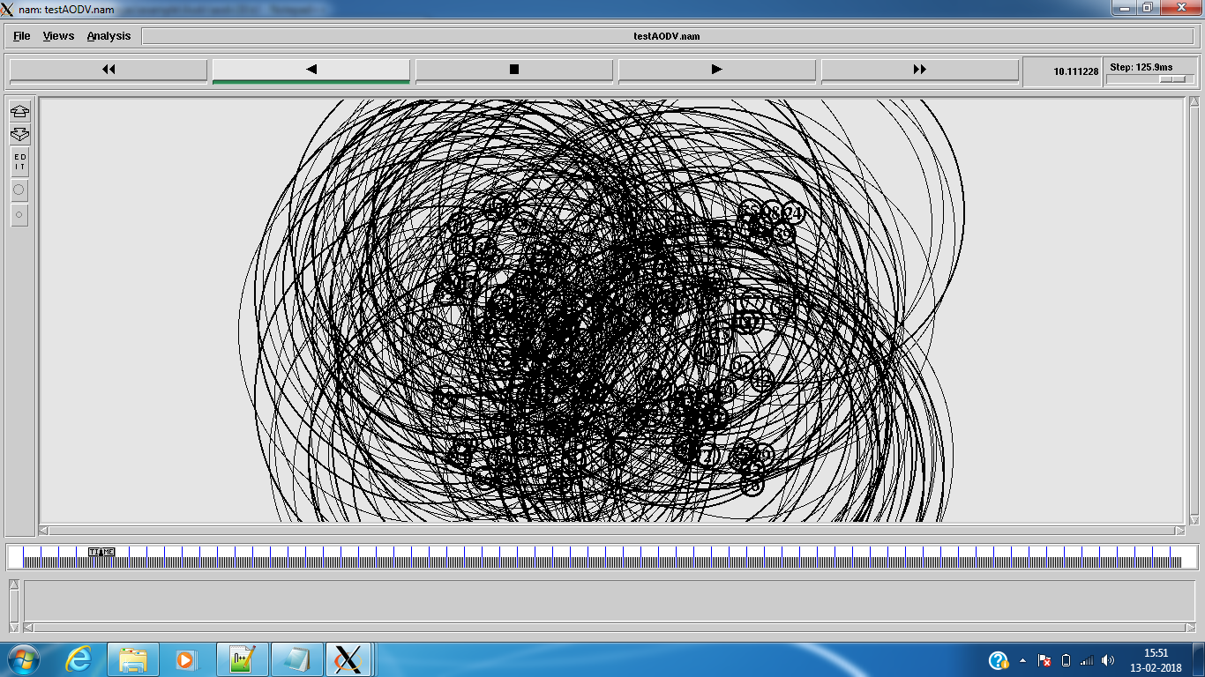  
**Fig 5.9 V2V communication – Scenario 1**

Here, irrespective of the number of nodes present, only 5 nodes communicate while others act as routers.

**Fig 5.10 PDR for V2V – Scenario 1**

|  |  |  |  |
| --- | --- | --- | --- |
|  | Packet Sent | Packet Received | Packet Delivery Ratio |
| No. of Nodes : 5 | 22039 | 21274 | 96.53 |
| No. of Nodes : 10 | 18059 | 17439 | 96.57 |
| No. of Nodes : 25 | 20736 | 20325 | 98.02 |
| No. of Nodes : 50 | 18737 | 18236 | 97.33 |
| No. of Nodes : 100 | 21359 | 20895 | 97.83 |

**Table 5.1 PDR for V2V – Scenario 1**

**Fig 5.11 E2E delay for V2V – Scenario 1**

|  |  |
| --- | --- |
|  | Average Delay(ms) |
| No. of nodes: 5 | 765.85 |
| No. of nodes: 10 | 752.668 |
| No. of nodes: 25 | 832.259 |
| No. of nodes: 50 | 855.477 |
| No. of nodes: 100 | 741.478 |

**Table 5.2 E2E delay for V2V – Scenario 1**

The results are tabulated and analysed and it is found that results are optimal in terms of both parameters – High PDR and low E2E (A delay of less than 1 second is very good such that message can reach its destination quick and the driver is alerted)

**Scenario 2:**

Since the results from scenario 1 are optimal, the idea is now extended where every node communicates with every other node by broadcasting messages. In order to prevent broadcast storm, the communication is restricted in a way that at one instant, one node transmits data to one destination directly or through ad hoc and once that communication is completed, the next one is started. Thereby, even with nodes broadcasting packets, extreme congestion is prevented and packet loss is reduced.

For example, if 100 nodes are in an area,

Node 1 will communicate with other 99 nodes, Node 2 with the other 99 and so on such that link is established between every nodes.

But when Node 1 needs to send a data to Node 25, it first checks for the paths available to Node 25 and selects the shortest path available. Thus the data packet reaches node 25 directly or through ad hoc. But when communication between node 1 & node 25 is taking place, node 1 doesn’t send data to other nodes since if node 1 sends data to every node at the same time, heavy congestion can take place. Also, other nodes send data at that instant in a similar fashion. Thus, maximum interconnection is established and congestion is also prevented.

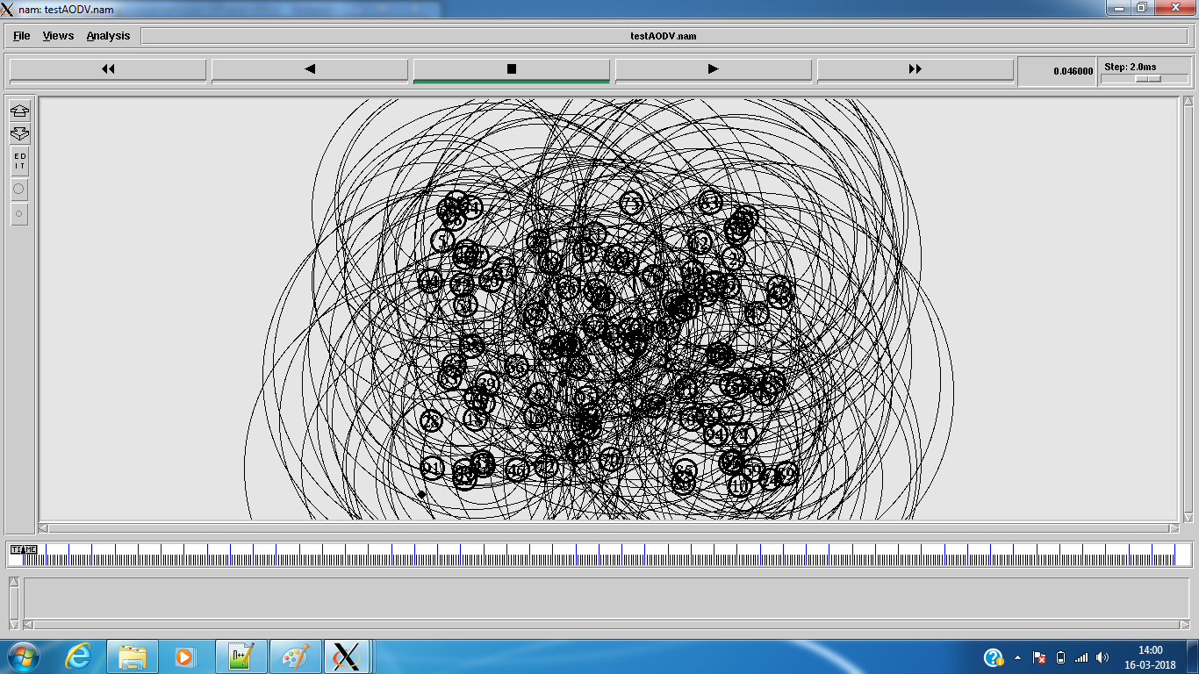  
**Fig 5.12 V2V communication – Scenario 2**

**Fig 5.13 PDR for V2V – Scenario 2**

|  |  |  |  |
| --- | --- | --- | --- |
|  | Packet Sent | Packet Received | Packet Delivery Ratio |
| No. of Nodes: 5 | 12456 | 12260 | 98.43 |
| No. of Nodes: 10 | 14485 | 14324 | 98.89 |
| No. of Nodes: 25 | 12089 | 11745 | 97.15 |
| No. of Nodes: 50 | 15925 | 15768 | 99.01 |
| No. of Nodes: 100 | 13934 | 13689 | 98.24 |

**Table 5.3 PDR for V2V – Scenario 2**

**Fig 5.14 E2E delay for V2V – Scenario 2**

|  |  |
| --- | --- |
|  | Average Delay(ms) |
| No. of Nodes: 5 | 560.696 |
| No. of Nodes: 10 | 448.075 |
| No. of Nodes: 25 | 633.474 |
| No. of Nodes: 50 | 672.792 |
| No. of Nodes: 100 | 534.634 |

**Table 5.4 E2E delay for V2V – Scenario 2**

Thus, it is found that the results are satisfactory even for the case of broadcast.

**5.5.4 VANET – MANUAL**

Once the V2V and I2I communication are checked individually for their performance, they are now combined for a complete VANET scenario. Also, before real-time simulation, the simulation is checked by designing a manual scenario.

1. Manually created some RSUs & Vehicles and enabled communication between every nodes present in the topography.
2. RSUs exchange data btw themselves & transmit info to vehicles.
3. Vehicles communicate between themselves via vehicles/RSU and also transmit packets to RSUs acknowledging their presence.
4. Implemented for different number of vehicles and tested the efficiency.

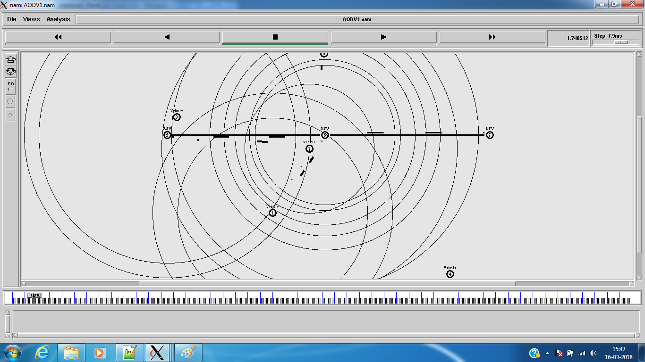

**Fig 5.15 VANET Manual – 5 nodes**

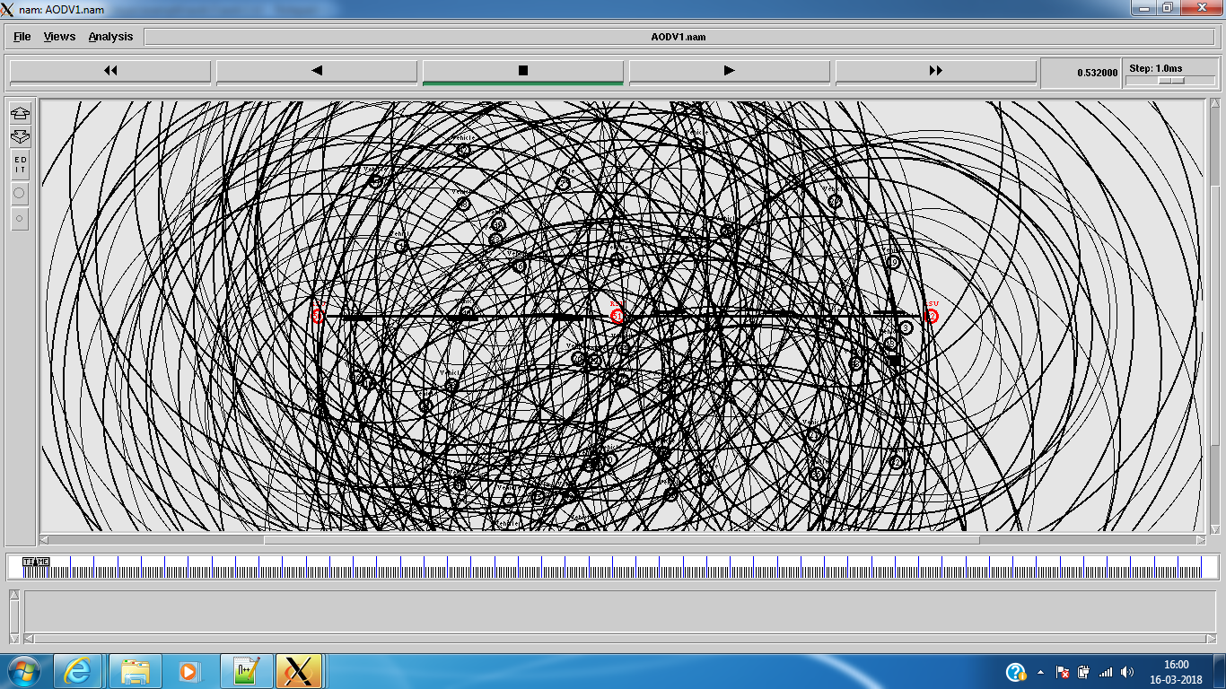

**Fig 5.16 VANET Manual – 50 nodes**

**Fig 5.17 PDR for VANET Manual**

|  |  |  |  |
| --- | --- | --- | --- |
|  | Packet Sent | Packet Received | Packet Delivery Ratio |
| No. of vehicles: 5 | 33687 | 33393 | 99.13 |
| No. of vehicles: 10 | 33574 | 33135 | 98.69 |
| No. of vehicles: 25 | 32005 | 31289 | 97.76 |
| No. of vehicles: 50 | 30108 | 28979 | 96.25 |
| No. of vehicles: 100 | 29774 | 27578 | 92.62 |

**Table 5.5 PDR for VANET Manual**

**Fig 5.18 E2E delay for VANET Manual**

|  |  |
| --- | --- |
|  | Average Delay |
| No. of Nodes: 5 | 192.267 |
| No. of Nodes: 10 | 204.886 |
| No. of Nodes: 25 | 219.986 |
| No. of Nodes: 50 | 143.407 |
| No. of Nodes: 100 | 142.825 |

**Table 5.6 E2E delay for VANET Manual**

**5.5.5 VANET – REAL TIME**

**Conversion of SUMO to Ns2:**

Using SUMO, we generated the traffic model. We need to transfer the traffic model information to Ns2 in order to establish communication between them.

The conversion is done as follows:

1. Command: **sumo -c map.sumo.cfg --fcd-output map.sumo.xml**
2. The SUMO configuration file is converted into a XML file format.
3. Command: **python traceExporter.py --fcd-input map.sumo.xml --ns2config-output map.tcl --ns2mobility-output mobility.tcl --ns2activity-output activity.tcl**
4. Using Trace Exporter, the SUMO xml file is converted into TCL file. Thereby three different files are created:
   1. Activity file: Various start and stop time of vehicle movements are stored in the **‘activity.tcl’** file.
   2. Mobility file: The routes to be followed by various vehicles are stored in the **‘mobility.tcl’** file
   3. Base tcl file: The information about the topography, number of vehicles and the simulation start and stop time are stored in the **‘map.tcl’** file

Thereby, Ns2 executable files are obtained.

**Establishing Real-time VANET scenario:**

1. Once the executable files are obtained, add a simple wireless scenario using AODV protocol.
2. Enable communication links between every vehicle and observe performance and movements of vehicles (nodes).
3. Based on various movements of vehicles, place RSUs wherever needed in order to achieve maximum coverage.
4. Enable I2I communication and V2I communication and design for complete connectivity of all nodes present in the topography.

Thereby, a complete VANET model is designed for real-time scenarios and the performance is checked.

**5.6 OVERALL REAL-TIME SIMULATION:**

**5.6.1 KATHIPARA SCENARIO**

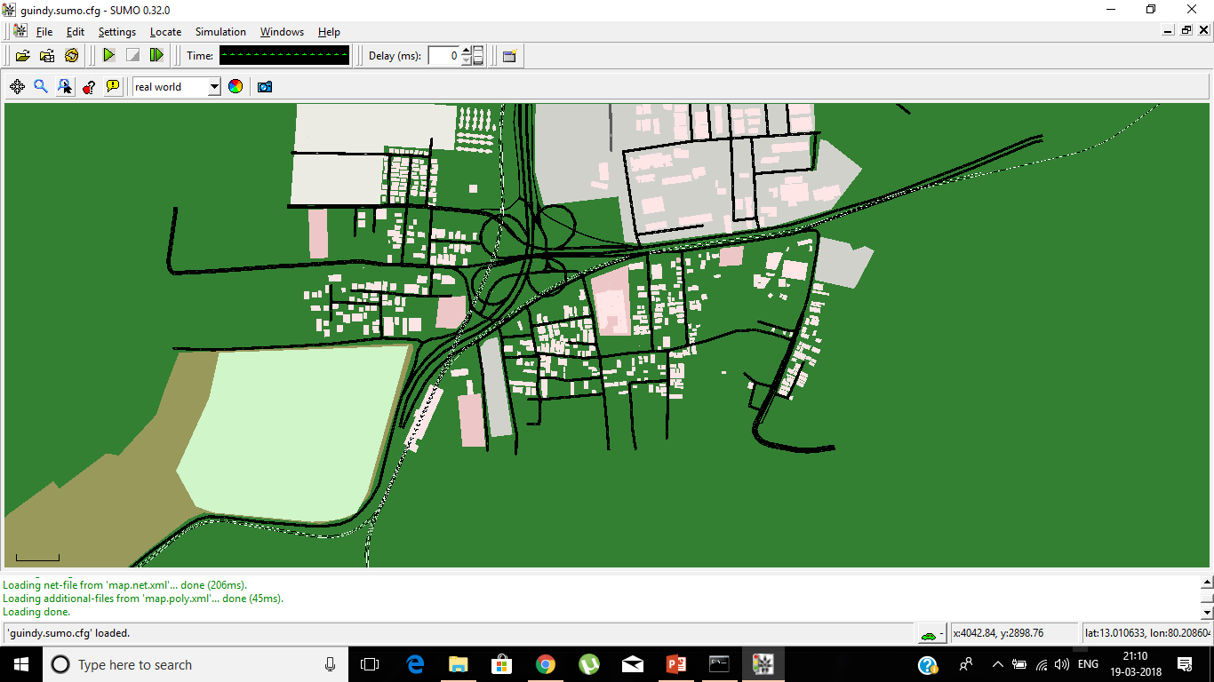  
**Fig 5.19 SUMO file - Kathipara**

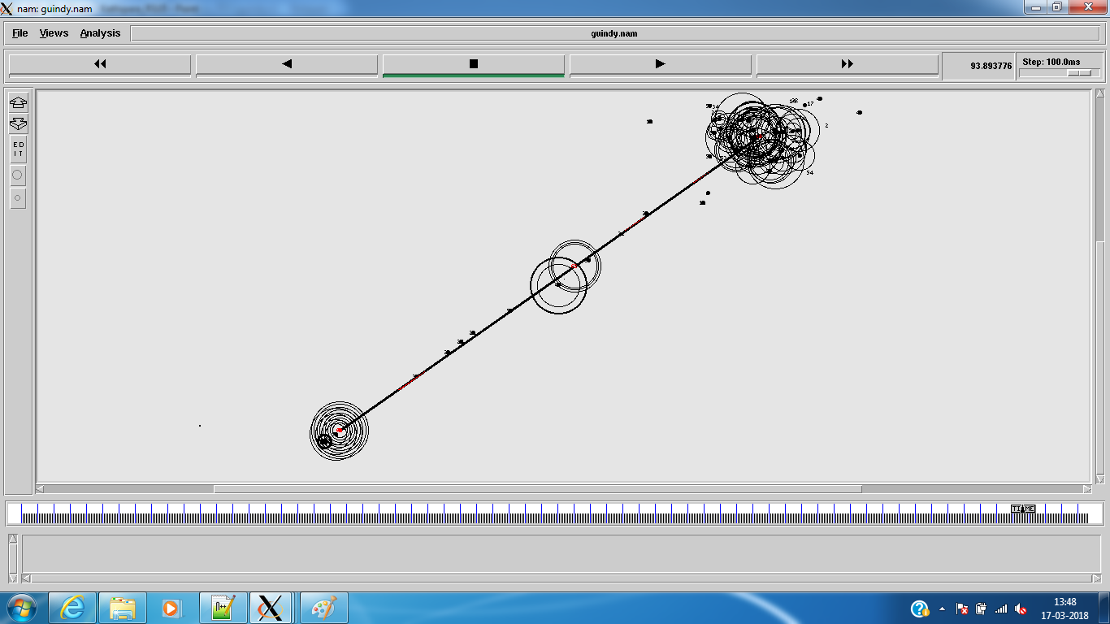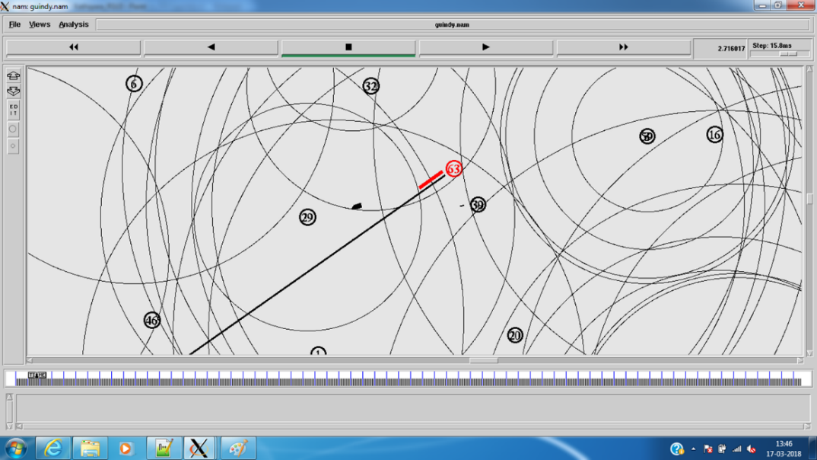  
**Fig 5.20 Ns2 file – Kathipara**

**5.6.2 T.NAGAR SCENARIO**

**  
Fig 5.21 SUMO file – Tnagar  
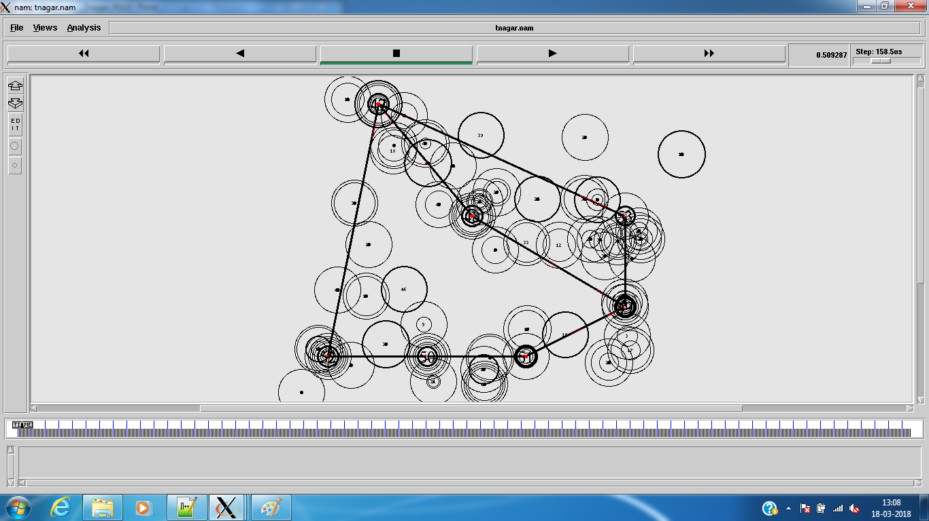  
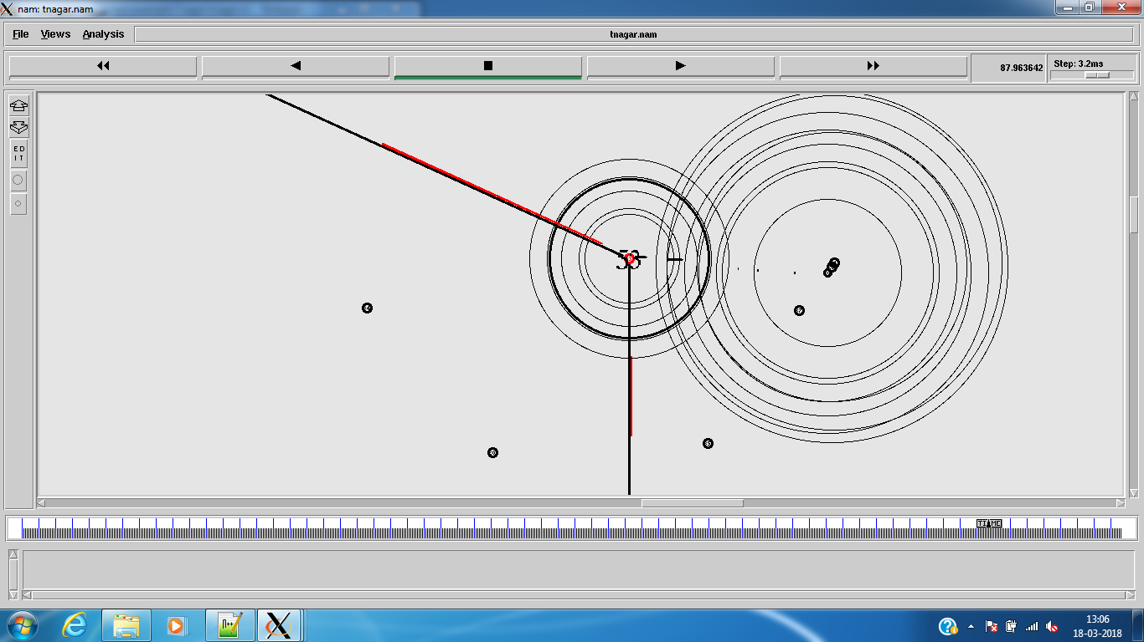  
Fig 5.22 Ns2 file – Tnagar**

Thereby, for Kathipara and T Nagar which exhibits dense traffic regularly can be managed with lower number of RSUs since high coverage can be achieved from the dense population of vehicles. In case of an occurrence of any event and if a vehicle is in the range, the vehicle can carry the data packet from that location to the RSU directly or through ad hoc. This is most likely to occur as vehicles are generally expected to be present every few metres. Thereby the message alert can be broadcasted to every commuter through vehicles/RSUs.

**5.6.3 VILLAGE SCENARIO**

**  
Fig 5.23 SUMO file – Village**

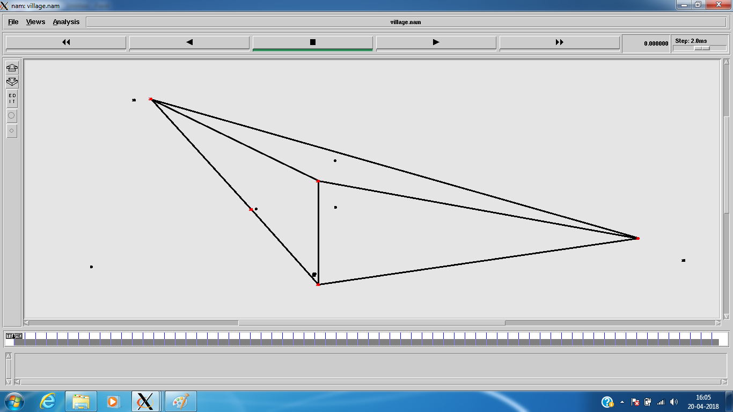

**Fig 5.24 Ns2 file - Village**

**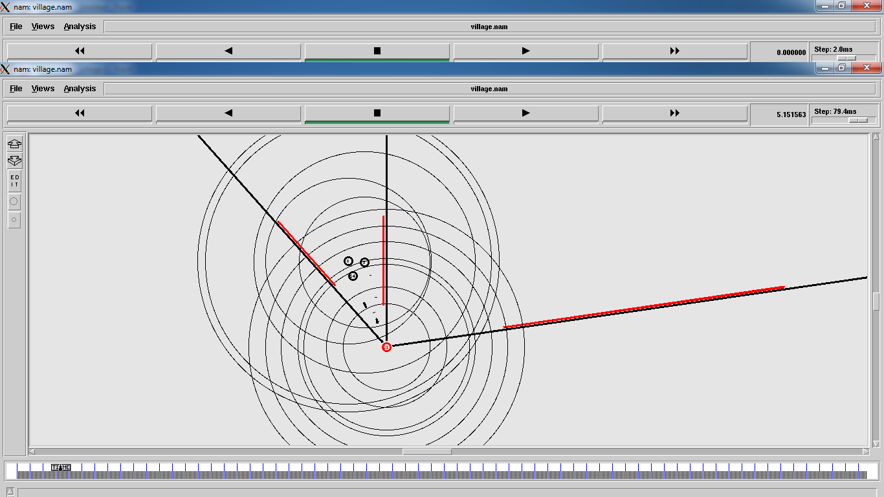  
Fig 5.25 Village VANET scenario**

Villages in India are under-developed with very much damaged roads, therefore this information must reach the vehicles coming behind alerting them of damaged roads ahead ensuring safety to them- which is our primary objective. The number of vehicles in villages are less therefore our first priority of vehicles to vehicle communication weakens here. Therefore more number of RSUs, which are connected through some sort of gateway, are much needed here to pass information.

In our scenario we have considered the village of KADAMBUR which is in integral part of Tamil Nadu. We implemented wireless scenario in this village with the help of sumo software, we analysed how the mobility of vehicle is in villages first and then converted the SUMO files to Ns2.

Once the mobility and topography information are derived from SUMO, wireless scenario is installed and V2V, I2I and V2I communication are established and the performance is analysed.

Thus, we simulated VANET scenarios which possess regular and expected traffic – generally densely populated (Kathipara, Tnagar) or generally sparsely populated (Village). Next we simulate a scenario with irregular traffic – Highway.

**5.6.4 HIGHWAY SCENARIO**

**  
Fig 5.26 SUMO file – Highway  
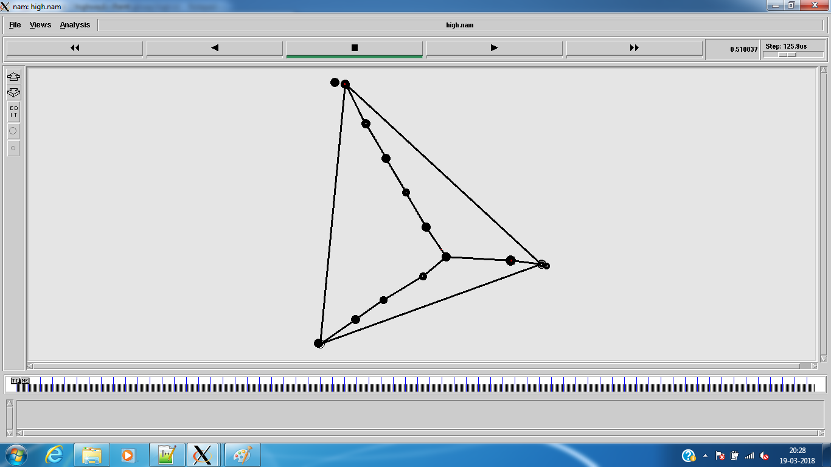  
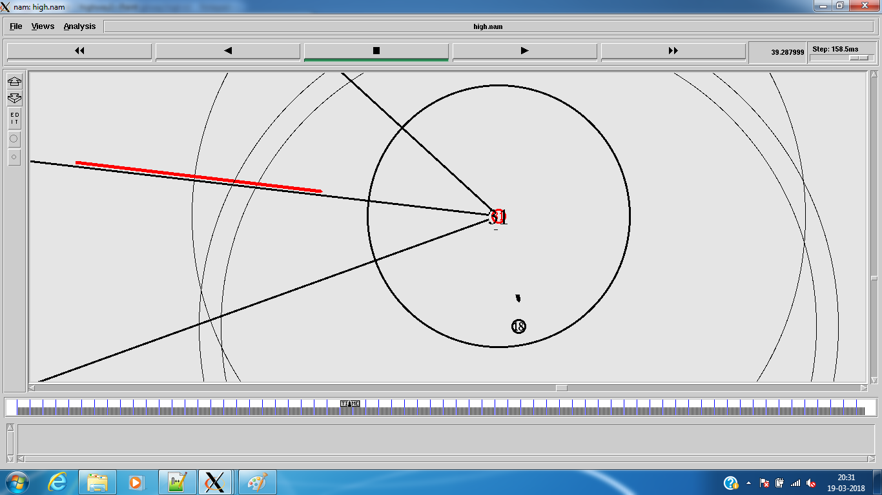  
Fig 5.27 Ns2 file – Highway**

The scenario of highway is a completely different one because in highways, the vehicle population may be high at some times and very low during different duration and therefore establishing a communication model between them becomes a difficult task.

In highways there is a need of higher number of RSUs along the road as any vehicle suffering from accidents or road damage ahead can be alerted immediately, even when no vehicle is present in that region.

Any event occurred at a densely vehicular populated area can reach the necessary destination via vehicles itself since they would be present in large number (in case of an RSU not in range). But in a highway, it can’t be blindly assumed that an alert needed to be transmitted can reach its destination immediately through a vehicle alone. A vehicle travelling, passing through the event occurrence can carry the data to a nearby RSU or the desired destination. But, cases can occur in which no vehicle is in the range for a long time. Hence, the alternative requirement is the RSUs. Hence they must be placed in larger number than in an area with higher population. Hence, here we have simulated with a higher number of RSUs taking the factor of lower number of vehicles. Therefore it is necessary for simulation of highways in SUMO to see how vehicles can communicate in such scenarios in real time and how stable information transfer can take place. We have simulated for the NH-52 highway. Based on the vehicle movements, RSUs are placed in order to achieve maximum coverage and connectivity. But the number of RSUs placed are higher in number due to irregularity in traffic conditions.

Using the simulation files, we then make analysis in terms of Packet Delivery Ratio and Average End-to-End delay for the various real-time VANET scenarios designed.

**5.6.5 ANALYSIS OF VANET – REAL TIME**

**Fig 5.28 Analysis of VANET-Real time**

|  |  |  |
| --- | --- | --- |
|  | Packet Delivery Ratio | Average Delay(ms) |
| T Nagar | 98.77 | 60.1012 |
| Kathipara | 97.86 | 97.9086 |
| Highway | 99.32 | 17.9835 |
| Village | 99.45 | 55.2659 |

**Table 5.7 Analysis of VANET-Real time**

**Inference:**

From the results obtained, it is found that the Packet Delivery Ratio and Average End-to-End delay are optimal for every scenario.

1. The PDR is always >90% and it can be concluded that most of the data packets generated reach the intended destination.
2. The Delay is also found to be <100ms and it is very much satisfactory for transferring information to vehicles.

Therefore it can be said that the message alerts reach every commuter in required time interconnected in the VANET scenario.

**5.7 VANET FOR BOATS – SIMULATION**

We simulate the VANET scenario for boats. Here, buoys are connected to the base station at land via satellite and messages are broadcasted from buoys to the boats.

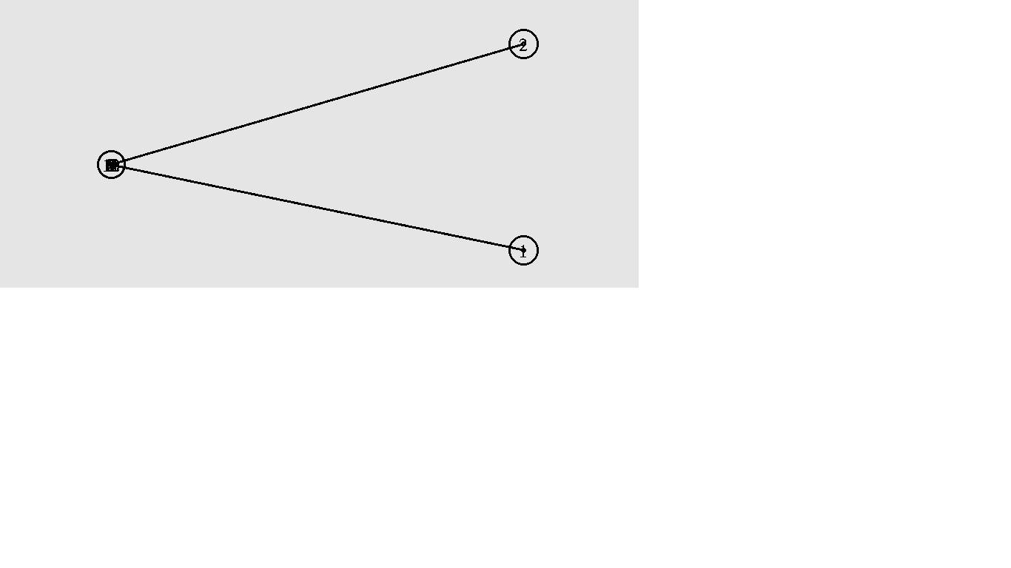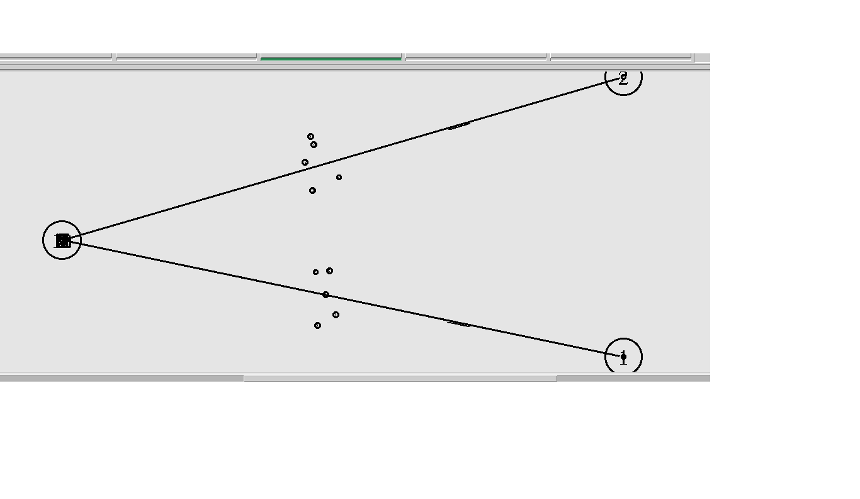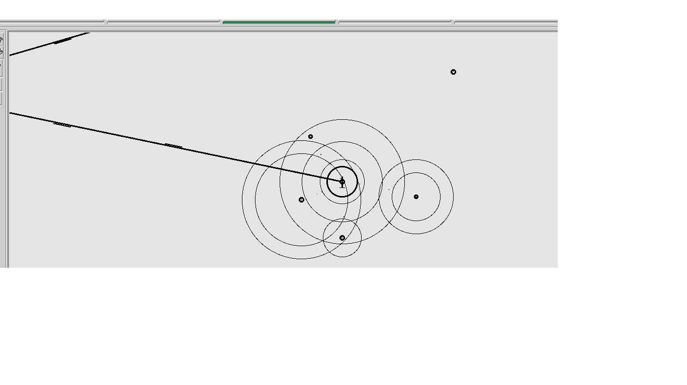

Buoy

Buoy

Satellite

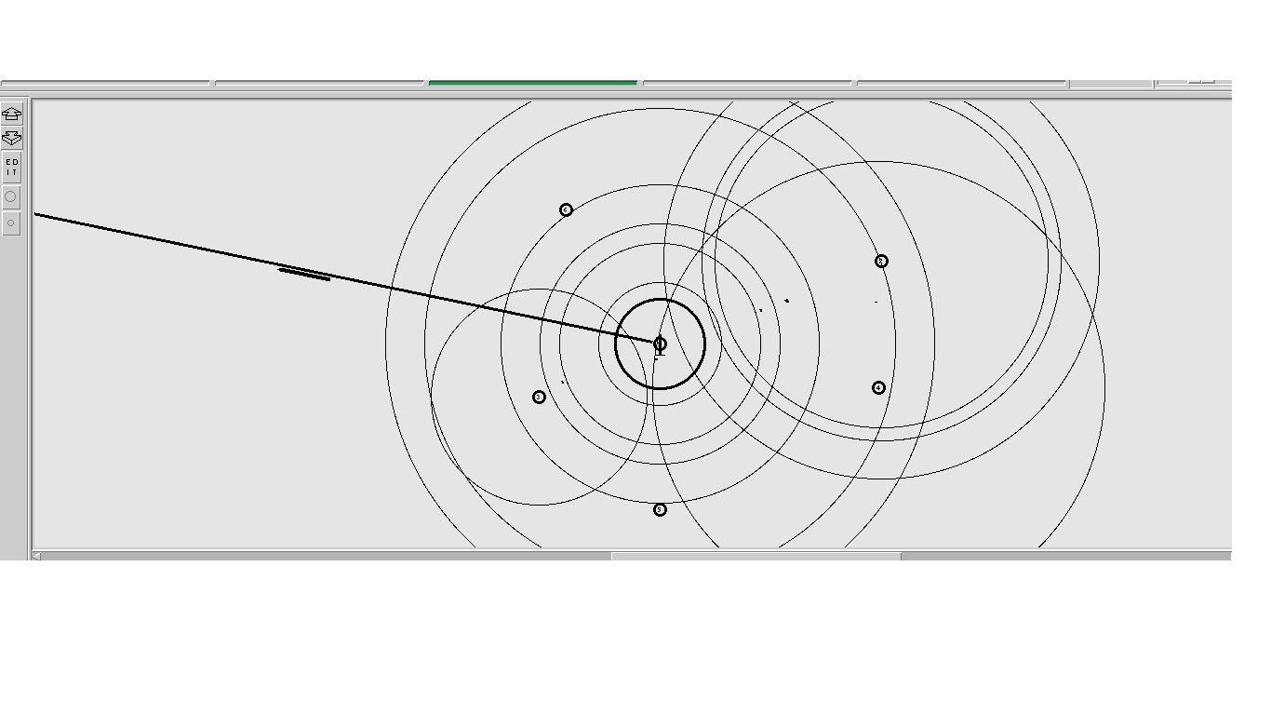

**Fig 5.29 VANET for boats – Simulation**

We have set up a simulation scenario. We have simulated by establishing a node for satellite, buoys and boats. The area surrounding the buoys is assumed to be fishing zone. Buoys are always connected with satellites. But buoys connect with the boats for every interval of time which we have set. In figure-1, circle 1 and circle 2 are the buoys and the third circle is the satellite. The wired connection is just to indicate that they are always connected but technically wirelessly. In figure-2, it indicates boats going to fishing zone in groups. These boats when they are inside the range of buoy they start to communicate with each other and also with the buoy which is shown in figure -3. Each boat will be fixed with an equipment to receive or send any messages. Each boat will be using TCP packets because it is connection – oriented and every boat will have an IP address too. The buoy will have a routing table to know what are the boats are in range. The buoy will receive a packet for example every 5 seconds from all the boats and it will send an acknowledgment and so this way it knows that all the boats are in range and no one is lost. In figure-4 , a boat is gone out of the range and so in this case the buoy will not receive a packet . The buoy will wait for some and still if not receives the packet, the buoy will send a packet to other boats with a message that a boat is gone missing.

**Analysis:**

Packets Sent: 38503

Packets Received: 38491

Packets Delivery Ratio: 99.97%

**Inference:** The PDR is found to be almost perfect and thus information is communicated to its destination and thus the boat is alerted.

**CHAPTER VI**

**CONCLUSION AND FUTURE WORK**

**6.1 CONCLUSION**

In this project, we have successfully established Vehicle-Vehicle, Vehicle-RSU and RSU-RSU communication and have executed simulation of real time scenarios of Kathipara, T.nagar, Highways, Village and analysed the traffic and communication for each model through an ad-hoc network using AODV protocol. We have also analysed the packet delivery ratio and average delay and also eliminated any errors which have occurred during the course of this project, in order to establish reliable communication which can used in real time situation.

For the boat scenario, we were able find a possible design which could benefit thousands of lives along the coast. The establishment of boat to boat and boat to buoy communication, would certainly benefit fishermen in communicating alerts with the shore and increase their safety in the midst of the sea. We have proposed a suitable solution to the problem supporting with simulation results and analyses.

**6.2 FUTURE WORK**

**6.2.1 LAND SCENARIO**

Vehicle to vehicle communication is a next-gen technology. In highly populated country like India, where thousands of vehicles are sold every day and millions of vehicles are on the road, the day is not far when vehicles will communicate with each other in order to avert traffic congestion, avoid accidents etc. As a possible future extension, it can be proposed that this VANET design can be combined with the existing Google Maps in order to automatically update the maps with this information of even small road-blocks, which in current is only getting updated about big construction sites, that too manually. Also, if the event of accidents, road-damages are dynamically updated for every few minutes, the commuters can find a possible alternate route using the google maps and also communicate this information with other drivers in the area, thereby avoiding much delay in the accident area and avoiding congestion.

**6.2.2 MARINE SCENARIO**

ISRO is striving harder day by day to come out with an effective solution for the fishermen. The proposed model for the communication of boats can be extended to enable communication even with the submarines and also can be used for defence purposes.

**REFERENCES**

# [1] [Alysonde Jesus dos Santos](https://www.sciencedirect.com/science/article/pii/S2214209615300140#!), [Luís Henrique, M. K. Costa](https://www.sciencedirect.com/science/article/pii/S2214209615300140#!), [Marcusde Lima](https://www.sciencedirect.com/science/article/pii/S2214209615300140" \l "!)

# [Braga](https://www.sciencedirect.com/science/article/pii/S2214209615300140" \l "!), [Pedro Braconnot Velloso](https://www.sciencedirect.com/science/article/pii/S2214209615300140#!), [Yacine Ghamri-Doudane](https://www.sciencedirect.com/science/article/pii/S2214209615300140#!), “Capacity analysis of a delay and disruption tolerant network in the Amazon basin”, IEEE, 2014

# [2] C. Suganthi Evangeline and S.Appu, “An Efficient Data Transmission in VANET Using Clustering Method”, Intl. Journal of Electronics and Telecommunications, 2017

## [3] Dineshkumar Singh, Sanjay Kimbahune and Veerendra Veer Singh, “Strategy for Deep Sea Communication or Safe Fisheries”, [Journal of ICT Standardization](https://www.riverpublishers.com/journal.php?j=JICTS/4/3/2), 2017

# [4] [Fengzhong Qu](https://ieeexplore.ieee.org/search/searchresult.jsp?searchWithin=%22Authors%22:.QT.Fengzhong%20Qu.QT.&newsearch=true), [Zhihui Wu](https://ieeexplore.ieee.org/search/searchresult.jsp?searchWithin=%22Authors%22:.QT.Zhihui%20Wu.QT.&newsearch=true), [Fei-Yue Wang](https://ieeexplore.ieee.org/search/searchresult.jsp?searchWithin=%22Authors%22:.QT.Fei-Yue%20Wang.QT.&newsearch=true), “A Security and Privacy Review of VANETs”, IEEE, 2015

[5] Geetanjali Singh, Neelima Chakrabarty, Kamini Gupta, “Traffic Congestion Detection and Management Using Vehicular Ad-Hoc Networks (VANETs) In India”, in International Journal of Advanced Computer Technology (IJACT) ISSN: 2319-7900, 2014

[6] Jyoti Jain, Nidhi Chahal, “A Review on Vanet, Types, Characteristics and Various Approaches”, International Journal of Engineering Sciences & Research Technology ISSN: 2277-9655, 2016

[7] K. Swathi, V. Sivanagaraju, A.K.S. Manikanta, S. Dileep Kumar, “Traffic Density Control and Accident Indicator Using WSN”, in International Journal of Modern Science and Technology ISSN: 2455-3778, 2016

# [8] [Komal Mehta](https://ieeexplore.ieee.org/search/searchresult.jsp?searchWithin=%22Authors%22:.QT.Komal%20Mehta.QT.&newsearch=true), [L. G. Malik](https://ieeexplore.ieee.org/search/searchresult.jsp?searchWithin=%22Authors%22:.QT.L.%20G.%20Malik.QT.&newsearch=true), [Preeti Bajaj](https://ieeexplore.ieee.org/search/searchresult.jsp?searchWithin=%22Authors%22:.QT.Preeti%20Bajaj.QT.&newsearch=true), “VANET: Challenges, Issues and Solutions”, IEEE, 2014

# [9] [Md Shahzamal](https://ieeexplore.ieee.org/search/searchresult.jsp?searchWithin=%22Authors%22:.QT.Md%20Shahzamal.QT.&newsearch=true), [Md Firoz Pervez](https://ieeexplore.ieee.org/search/searchresult.jsp?searchWithin=%22Authors%22:.QT.Md%20Firoz%20Pervez.QT.&newsearch=true), “Mobility Modelling Of Marine Fishing Boats For Communication Network Simulation”, IEEE, 2016

# [10] [Nimra Anjum](https://ieeexplore.ieee.org/search/searchresult.jsp?searchWithin=%22Authors%22:.QT.Nimra%20Anjum.QT.&newsearch=true), [Nasreen Badruddin](https://ieeexplore.ieee.org/search/searchresult.jsp?searchWithin=%22Authors%22:.QT.Nasreen%20Badruddin.QT.&newsearch=true), [Micheal Drieberg](https://ieeexplore.ieee.org/search/searchresult.jsp?searchWithin=%22Authors%22:.QT.Micheal%20Drieberg.QT.&newsearch=true), “Simulation of traffic congestion detection using VANETs”, IEEE, 2014